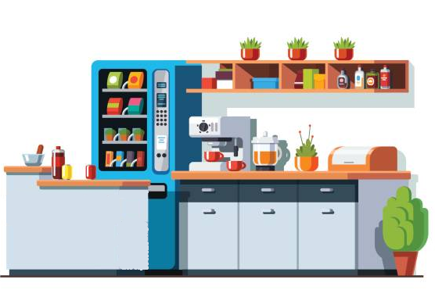
PLEASE LIMIT BREAK ROOM OCCUPANCY TO NO MORE THAN (#) PEOPLE & MAINTAIN 6 FEET DISTANCE

6 FEET

THANK YOU!

