How to comment on this document:
- This document is locked for editing and cannot be modified using traditional editing or track changes methods.
- Comments can be made on specific lines of this document using the ‘New Comment’ feature in the Review Tab.
- There are two (2) methods for adding a new comment:
  - Method 1: Click on the line of text where you would like to add a comment, then select ‘New Comment’ in the Review tab to add a comment.
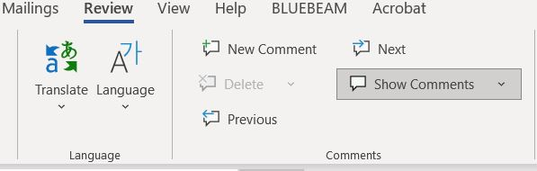

  - Method 2: Right-click on the line of text where you would like to add a comment, and select ‘New Comment’ from the provided menus.
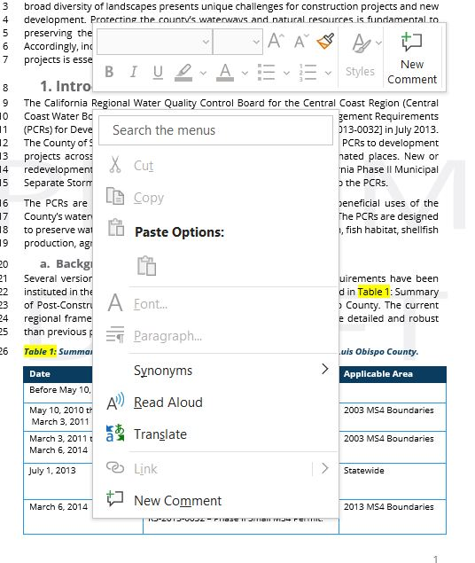
- When you have finished adding your comments:
  - Save the word document with your initials at the end of the file name.
  - Return the file via email to mattv@wallacegroup.us
  - Comments are due by April 28, 2023

Applicant and Engineer Information
Departmental Use Only
_________

Do Not Mark

Applicant Name: | Daytime Phone:
Mailing Address: | Zip Code:
Email Address:

Engineer Name: | Daytime Phone:
Mailing Address: | Zip Code:
Email Address:

Project Information

☐ Preliminary entitlements-  Subdivision or Land Use Permit approval | ☐ Final-  Building and/or Grading Permit for construction
Land Use Permit Number(s): | Building Permit Number(s):
Project Address: | Assessor’s Parcel Number (APN):
Brief narrative description of project:

Impervious Surface Areas
Calculate and identify all items listed in the table below.
New Impervious Area (square feet):
Example: New buildings, new pavement, etc.
Replaced Impervious Area (square feet):
Example: Buildings demolished to build a new parking lot or vice versa
Reduced Impervious Area (square feet):
Example: Pavement/buildings demolished with area scarified, re-vegetated, replaced with pervious pavers, etc.
Credit for Reduced Impervious Area (square feet):
If [New + Replaced) > Reduced, use Credit = 0
If (New + Replaced) < Reduced, use Credit = Reduced
Net Impervious Area (square feet) = (New + Replaced) - Credit

Stormwater Performance Requirements
The following table summarizes the mandatory Performance Requirements based on the amount of impervious surface area that is created or replaced. Please review this table to determine which requirements apply to the project.
Net Impervious Surface  square feet | Performance Requirements
 | Performance Requirement #1 | Performance Requirement #2 | Performance Requirement #3 | Performance Requirement #4
0 - 2,499 | Complete Stormwater PCR Waiver Request Form
2,500 - 4,999 | 
5,000 - 14,999 |  |  *
15,000 – 22,499 |  |  | 
≥ 22,500 |  |  |  | 
* Not applicable for a single-family residence

Check the applicable performance requirements and indicate whether the project meets the requirement:
Performance Requirement #1- Site Design | Requirement met? ☐ Yes ☐ No
(Projects that meet Performance Requirement 1 only, complete this SWCP application and attach any applicable exhibits)
Performance Requirement #2- Water Quality Treatment | Requirement met? ☐ Yes ☐ No
Performance Requirement #3- Runoff Retention | Requirement met? ☐ Yes ☐ No
Performance Requirement #4- Peak Management | Requirement met? ☐ Yes ☐ No

- Projects that create or replace less than 2,500 square feet of impervious surface area must complete and submit the Stormwater PCR Waiver Request Form.

- Projects required to meet Performance Requirement 1 only, must complete this SWCP application and attach any applicable exhibits.

- Projects required to meet Performance Requirement 2, 3, or 4, must submit this SWCP application in addition to a complete Stormwater Control Plan using the County provided template.

Performance Requirement #1: Site Design Measures Applicants Can Incorporate to Reduce Stormwater Impacts
Applicants are encouraged to reduce stormwater impacts associated with development and redevelopment.

Performance Requirement 1: Site Design and Runoff Reduction Summary
Minimize stormwater runoff by implementing one or more of the following Site Design Measures.

Selected Design Measures must be clearly referenced on the project plans.
Site Design Measures | Implemented? | If Yes, provide Plan Sheet / Detail location | If No, provide an explanation below
Roof runoff directed into cisterns or rain barrels for reuse? | ☐ Yes ☐ No
Roof runoff directed into vegetated areas (safely away from building foundations and footings)? | ☐ Yes ☐ No
Runoff from sidewalks, walkaways, and/or patios directed onto vegetated areas (safely away from the building foundations and footings)? | ☐ Yes ☐ No
Runoff from driveways and/or uncovered parking lots onto vegetated areas (safely away from the building foundations and footings)? | ☐ Yes ☐ No
Are bike lanes, driveways, uncovered parking lots, sidewalks, walkways, and patios constructed with permeable surfaces? | ☐ Yes ☐ No

Performance Requirement #1: Stormwater Site Design & Runoff Reduction Summary
For each of the following, please describe how this project has complied to the maximum extent practicable with the following site design and runoff reduction:
- Limit disturbance of creeks and natural drainage features.

- Minimize compaction of highly permeable soils.

- Limit clearing and grading of native vegetation at the site to the minimum area needed to build the project, allow access, and provide fire protection.

- Minimize impervious surfaces by concentrating improvements on the least-sensitive portions of the site, while leaving the remaining land in a natural, undisturbed state.

Certification*
I hereby certify that this project is designed to achieve full compliance with each of the applicable Central Coast Post-Construction Requirements.
Preparer Name:
Preparer Signature: | Date:
Was this application completed by a registered professional? ☐ Yes ☐ No
License Number: | License Type:
Stamp:
*Certification is required for projects subject to Performance Requirements 2, 3, or 4 and may be provided by a registered professional engineer, geologist, architect, and/or landscape architect.

