How to comment on this document:
- This document is locked for editing and cannot be modified using traditional editing or track changes methods.
- Comments can be made on specific lines of this document using the ‘New Comment’ feature in the Review Tab.
- There are two (2) methods for adding a new comment:
  - Method 1: Click on the line of text where you would like to add a comment, then select ‘New Comment’ in the Review tab to add a comment.
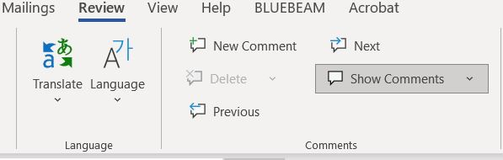

  - Method 2: Right-click on the line of text where you would like to add a comment, and select ‘New Comment’ from the provided menus.
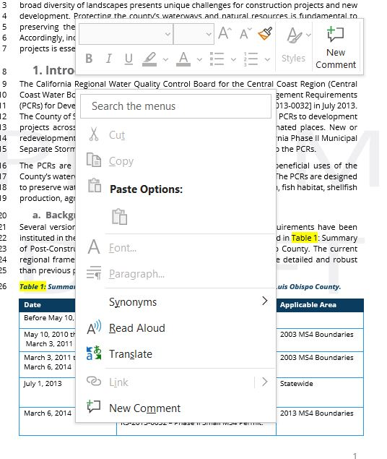
When you have finished adding your comments:
- Save the word document with your initials at the end of the file name.
- Email your copy with comments to: mattv@wallacegroup.us

County of San Luis Obispo
Post-Construction Stormwater Guidebook
FINAL DRAFT

April 2024

1. Introduction 1
a. Background 1
b. Purpose of this Guidebook 2
2. Project Triggers 7
a. Geographic Areas 7
b. Previously vested projects 7
c. Project triggers and exemptions 8
d. Site Determination 10
e. Impervious surfaces, surface types 10
f. Performance Requirements Summarized 12
3. Submittal Process Overview 23
a. Timeline for Submittals and Required Documents 23
4. Site Assessment 26
a. Opportunities and Constraints Analysis 26
b. Soil Classification 28
c. Depth to Groundwater 31
d. Geotechnical Constraints 31
e. Hazardous Materials or Contamination 32
f. Natural Areas and Existing Vegetation 32
g. Special Considerations 33
h. Landscaping Requirements 36
i. Utility Conflicts 37
j. Site Definition and Run-On Control 38
k. Minimizing the Size of SCMs 38
5. Structural Stormwater Control Measures 39
a. Drainage Management Area Delineation 39
b. Structural Control Measure Types 41
c. Prioritization of Low Impact Development 43
d. Structural Stormwater Control Measure Selection 46
e. Bioretention and Biofiltration 49
f. Vegetated Swales and Buffer Strips 51
g. Proprietary units and specialized materials 54
h. Underground Infiltration Systems and Dry Wells 55
i. Pervious Pavement Systems 58
j. Sedimentation of Infiltration and Filtration Systems 59
k. High Pollutant Risk Sites 60
6. Calculations 62
a. Tributary DMA Calculations and Tabulations 62
b. Impervious and Pervious Surfaces 63
c. Infiltration and Percolation Rates 65
d. Structural SCM Sizing Calculations 65
e. Santa Barbara Technical Guide Calculator Tool 69
f. Credits for Redevelopment, PR#3 69
g. Underground Infiltration Systems and Dry Wells 69
h. County Drainage and Flood Control Calculations 69
7. Required Post-Construction Stormwater Submittals 70
a. Stormwater Control Plan Application (SWCP App) 70
b. Stormwater Control Plan, County Template 70
c. Drainage Report or Drainage Analysis 73
d. Operation and Maintenance Agreement 73
8. SCM Construction and Inspection 77
a. Construction and Inspection Checklists 77
b. Inspection Process and Frequency 77
c. Materials Specifications and field slips 78
d. Documenting field changes 78
e. Engineer’s Certification 78
9. Overview of Operations and Maintenance Agreements 79
a. Roles and Responsibilities Operations & Maintenance on Common Property 79
b. Roles and Responsibilities for Operations & Maintenance on Private Property 80
c. Roles and Responsibilities for Operations & Maintenance on Public Property 80
d. Inspections and maintenance following construction completion 81
e. Common maintenance findings 81
f. Mechanism to assure continued operations 82
g. Termination of Operations and Maintenance Agreements 82
10. Bibliography and References 84

LIST OF TABLES (Table numbering Updated in Final Draft.)
Table 1: Post-Construction Stormwater Guidebook revision and amendment log vii
Table 2: Summary of Post-Construction Stormwater Policies applied in San Luis Obispo County. 1
Table 3: Unregulated project criteria. 8
Table 4: Summary of post-construction performance requirements 14
Table 5: Examples of PR#1 site design strategies 15
Table 6: Runoff reduction strategy volume guidelines. 16
Table 7: PR#2 design criteria 17
Table 8: Opportunities and constraints summary table. 27
Table 9: Infiltration testing methods and appropriate factors of safety for SCM design. 30
Table 10: Site conditions supporting a technical infeasibility finding. 33
Table 11: Correction factors for calculating Equivalent Impervious Surface Area. 34
Table 12: Drainage management area sizing guidelines. 40
Table 13: Stormwater structural control measures. 41
Table 14: Rainwater harvesting crediting and drawdown. 46
Table 15: Minimum lateral setbacks for SCMs. 48
Table 16: Vegetated swale design criteria 52
Table 17: Vegetated buffer strip design criteria for PR#2 52
Table 18: Adjusted retention tributary area example. 62
Table 19: Approved C factors for constructed surface types 64
Table 20: Design infiltration rates based on Hydrologic Soil Groups 65
Table 21: Routing method criteria. 66
Table 22: Components of Private Operations and Maintenance Agreement 74
Table 23: Components of CC&Rs for stormwater feature operation and maintenance 75

List of Figures
Figure 1: Comparison of green and gray stormwater management strategies 3
Figure 2: Policies dictating post-construction stormwater runoff control standards 5
Figure 3: Impervious surface categories for determining project performance requirements. 11
Figure 4: Applicable performance requirements determination chart 13
Figure 5: Runoff reduction measures, PR#1 15
Figure 6: Example project #1, impervious area metrics 20
Figure 7: Example project #2, net impervious area reduction example 21
Figure 8: Preliminary SWCP objectives 23
Figure 9: Required submittals with final stormwater control plans 25
Figure 10: Protection of sensitive biological resources can be integrated as compliance with PR#1. 32
Figure 11: Recessed vegetated median with valley drain and curb cut to accept stormwater. 37
Figure 12: Utility infrastructure in a bioretention feature and obstructing a stormwater swale. 37
Figure 13 Downspout directed to site landscaping. 38
Figure 14: Low impact development prioritization framework. 44
Figure 15: Bioretention/biofiltration feature common construction characteristics. 50
Figure 16: Bioretention/Biofiltration planting zones. 51
Figure 17: Vegetated buffer strip design schematic. 53
Figure 18: Ratios of run-on drainage to pervious pavement systems. 59
Figure 19: Transition from pervious interlocking pavers to traditional pavers in ADA path of travel. 59
Figure 20: Simplified sizing method for bioretention facilities. 68

List of equations
Equation 1: Total new and replaced impervious area 12
Equation 2: Net impervious area 12
Equation 3: Retention tributary area. 62
Equation 4: Impervious ratio (i) to Runoff coefficient 'C' equation. 63
Equation 5: Retention volume calculation. 63
Equation 6: Multi-surface runoff coefficient calculation 64
Equation 7: Porchet Method 65
Equation 8: Bioretention facility surface area calculation. 67
APPENDICES
Appendix A: Hyperlinks and References
Appendix B: Opportunities and Constraints Analysis
Appendix C: Class V Wells and Underground Infiltration Systems
Appendix D: Plant Palettes
Appendix E: Example Projects
Appendix F: Structural Control Measure Inspection Checklists

Guidebook revisions and amendments
Low Impact Development (LID) is an evolving and adaptive concept, and best practices and design guidance are subject to revision as technologies are developed and refined. Revisions and amendments to this guide will be evaluated on a biennial basis. Updates and revisions will be noted in Table 2, the Guidebook Revision and Amendment Log.
Table 1: Post-Construction Stormwater Guidebook revision and amendment log
Date of Update | Section Updated | Page Updated | Update Summary Notes

Statement to Users
This guidebook is intended for use as a guidance document to support developing projects to comply with the Central Coast Post-Construction Requirements. The Central Coast Water Board does not approve or reject guidance documents and may differ in their interpretations of specific policy provisions.

Acronyms & Abbreviations
APN | Assessor’s Parcel Number
ADU | Accessory Dwelling Unit
BMP | Best Management Practice
BSM | Biofiltration Soil Media
CCM Case | Condition Compliance Monitoring Permit Case
CCRs | Covenants, Conditions, and Restrictions
Central Coast Water Board | Central Coast Regional Water Quality Control Board
COA | Conditions of Approval
CSD | Community Services District
DMA | Drainage Management Area
EISA | Equivalent Impervious Surface Area
EPA | Environmental Protection Agency
HOA | Homeowner’s Association
HSG | Hydrologic Soils Group
JADU | Junior Accessory Dwelling Unit
LID | Low Impact Development
MS4 | Municipal Separate Storm Sewer System, as defined in the Clean Water Act
MS4 Area | Areas regulated by the MS4 Phase II Permit.
NPDES | National Pollutant Discharge Elimination System
NRCS | Natural Resources Conservation Service (US Department of Agriculture)
O&M | Operations and Maintenance
PCRs | Regional Post-Construction Requirements, current version adopted by the Central Coast Water Board in July 2013. Resolution No. R3-2013-0032.
PR | Performance Requirements, as detailed in the Regional Post-Construction Requirements.
SCM | Stormwater Control Measure
sf | Square feet
SFD | Single Family Dwelling
USA | Urban Sustainability Area
WMZ | Watershed Management Zone

Definitions
Term | Definition
Best Management Practice (BMP) | A program, technology, process, citing criteria, operational method, or engineered system which when implemented prevents, controls, removes, or reduces stormwater pollution.  Source: Sonoma County Stormwater LID Technical Design Manual, 2020
Bioretention | A Stormwater Control Measure designed to retain stormwater runoff using vegetated depressions and soils engineered to collect, store, treat, and infiltrate runoff. Bioretention designs do not include underdrains.  Source: Central Coast Resolution R3-2013-0032, Post-Construction Requirements
Biotreatment or Biofiltration | A Stormwater Control Measure designed to detain stormwater runoff, filter stormwater through soil media and plant roots, and release the treated stormwater runoff to the storm drain system. Biotreatment systems include an underdrain.  Source: Central Coast Resolution R3-2013-0032, Post-Construction Requirements
Biofiltration Soil Media | Blended soil media intended to filter stormwater and support plant growth while minimizing the leaching of potential pollutants. Biofiltration Soil Media is also referred to as Engineered Soil Media and Bioretention Soil Media.  Source: County of San Diego County BMP Design Manual, 2020
C-Factor | Representation of a surface’s ability to produce runoff. Surfaces that produce higher quantities of runoff are represented by higher C-Factors (such as impervious surfaces.)  Source: Sonoma County Stormwater LID Technical Design Manual, 2020
Conditions of Approval | Requirements a jurisdiction may adopt for a project in connection with a discretionary action (e.g., issuance of a use permit). COAs may include features to be incorporated into the final plans for the project and may also specify uses, activities, and operational measures that must be observed over the life of the project.  Source: County of San Diego County BMP Design Manual, 2020
Detention | Temporarily holding or storing storm water runoff via a designed outlet (e.g., underdrain, orifice) to provide flow rate and duration control.  Source: County of San Diego County BMP Design Manual, 2020
Direct Infiltration | Infiltration via methods or devices designed to bypass surface soils and transmit runoff directly to subsurface soils. Examples of direct infiltration include infiltration trenches, underground chambers, and dry wells. Source: County of San Diego County BMP Design Manual, 2020. City of Gilroy, City of Morgan Hill, County of Santa Clara. Stormwater Management Guidance Manual for Low Impact Development & Post-Construction Requirements. June 2015.
Hydraulic Residence Time | The length of time between inflow and outflow that runoff remains in a SCM.  Source: County of San Diego County BMP Design Manual, 2020
Impervious Surface | A hard, non-vegetated surface area that prevents or significantly limits the entry of water into the soil mantle, as would occur under natural conditions prior to development. Common impervious surfaces include, but are not limited to, roof tops, walkways, patios, driveways, parking lots or storage areas, concrete or asphalt paving, oiled, or other surfaces which similarly impede the natural infiltration of stormwater. Open, uncovered retention/detention facilities shall not be considered as impervious surfaces for purposes of determining whether the thresholds for application of Performance Requirements are exceeded. However, for modeling purposes, open, uncovered facilities that retain/detain water (e.g., retention ponds, pools) shall be considered impervious surfaces.  Source: Central Coast Resolution R3-2013-0032, Post-Construction Requirements
Indirect Infiltration | Infiltration via facilities designed to hold runoff and allow it to percolate into surface soils. Runoff may reach groundwater indirectly or may be drained through subsurface pipes. Examples of indirect infiltration include bioretention, landscaped areas, and vegetated basins.  Source: County of San Diego County BMP Design Manual, 2020. City of Gilroy, City of Morgan Hill, County of Santa Clara. Stormwater Management Guidance Manual for Low Impact Development & Post-Construction Requirements. June 2015.
Low Impact Development | A stormwater and land use management strategy that strives to mimic pre-disturbance hydrologic processes of infiltration, filtration, storage, evaporation, and transpiration by emphasizing conservation, use of on-site natural features, site planning, and distributed stormwater management practices that are integrated into a project design.  Source: Central Coast Resolution R3-2013-0032, Post-Construction Requirements
New Development | Land disturbing activities that include the construction or installation of buildings, roads, driveways and other impervious surfaces. Development projects with preexisting impervious surfaces are not considered New Development.  Source: Central Coast Resolution R3-2013-0032, Post-Construction Requirements
Pervious Surface | A surface that allows varying amounts of stormwater to infiltrate into the ground. Examples include pasture, native vegetation areas, landscape areas, and permeable pavements designed to infiltrate.  Source: Central Coast Resolution R3-2013-0032, Post-Construction Requirements
Pretreatment | Removal of gross solids, including organic debris and coarse sediment, from runoff to minimize clogging and increase the effectiveness of SCMs.  Source: County of San Diego County BMP Design Manual, 2020
Replaced Impervious Surface | The removal of existing impervious surfaces down to bare soil or base course, and replacement with new impervious surface. Replacement of impervious surfaces that are part of routine road maintenance activities are not considered replaced impervious surfaces.  Source: Central Coast Resolution R3-2013-0032, Post-Construction Requirements
Repaired Impervious Surface | Surfaces that are repaired by practices that include overlay, slurry sealing, fog sealing, crack sealing, pothole and square cut patching, or re-surfacing with in-kind material without expanding the footprint of the impervious area. Repairs maintain the original line, grade, hydraulic capacity and overall footprint of the existing surface without disturbance of the base course.  Source: Central Coast Resolution R3-2013-0032, Post-Construction Requirements
Redevelopment | On a site that has already been developed, construction or installation of a building or other structure subject to the Permittee’s planning and building authority including: 1) the creation or addition of impervious surfaces; 2) the expansion of a building footprint or addition or replacement of a structure; or 3) structural development including construction, installation, or expansion of a building or other structure. It does not include routine road maintenance, nor does it include emergency construction activities required to immediately protect public health and safety.  Source: Central Coast Resolution R3-2013-0032, Post-Construction Requirements
Self-Retaining Area | (also called “zero discharge” areas) Areas designed to retain some amount of rainfall (by ponding and infiltration and/or evapotranspiration) without producing stormwater runoff. Self-Retaining Areas may include graded depressions with landscaping or pervious pavement.  Source: Central Coast Resolution R3-2013-0032, Post-Construction Requirements
Self-Treating Area | A portion of a Regulated Project in which infiltration, evapotranspiration and other natural processes remove pollutants from stormwater. The self-treating areas may include conserved natural open areas and areas planted with native, drought-tolerant, or LID appropriate vegetation. The self-treating area only treats the rain falling on itself and does not receive stormwater runoff from other areas.  Source: Central Coast Resolution R3-2013-0032, Post-Construction Requirements
Structural Stormwater Control Measure (SCM) | A manufactured facility, structural mechanism, or landscape feature designed and constructed to mitigate the adverse impacts of stormwater runoff (e.g. canopy, basin).  Source: Sonoma County Stormwater LID Technical Design Manual, 2020
Trash Amendment | An amendment to the State Water Resources Control Board’s Water Quality Control Plan for Ocean Waters and the Water Quality Control Plan for Inland Surface Waters, Enclosed Bays, and Estuaries of California that establishes a trash discharge prohibition and includes a strategy to provide “full capture” of trash from stormwater MS4 permits.  Source: Sonoma County Stormwater LID Technical Design Manual, 2020
Watershed Management Zone | A categorization of the urbanized portions of MS4 Area based on common key watershed processes and receiving water type (creek, marine nearshore waters, lake, etc.). The Central Coast Region is categorized into 10 WMZs,  Source: Central Coast Resolution R3-2013-0032, Post-Construction Requirements

Credits
This guidebook was prepared for the County of San Luis Obispo with the support of Wallace Group consultants. The County gratefully acknowledges the public agencies whose stormwater management and low impact development guidance documents provided valuable insight and information for this guidebook, including:
City of Gilroy, City of Morgan Hill, County of Santa Clara. 2015. “Stormwater Management Guidance Manual for Low Impact Development & Post-Construction Requirements.”
City of Salinas. 2021. “Stormwater Development Standards for New and Redevelopment Projects.”
City of San Diego, 2018. “The City of San Diego Storm Water Standards.”
County of Sonoma. 2017. “Storm Water Low Impact Development Technical Design Manual, Revised December 2020.”
County of Santa Barbara, Project Clean Water. 2017. “Stormwater Technical Guide for Low Impact Development, 2nd Edition.”
County of Orange. 2017. “South Orange County Technical Guidance Document for the Preparation of Conceptual/Preliminary and/or Project Water Quality Management Plans.”
California Department of Transportation, Division of Environmental Analysis. 2012. Biofiltration Swale Design Guidance.
Contra Costa Clean Water Program, 2022. Stormwater C.3 Guidebook, 8th Edition.
County of San Diego. 2020. “County of San Diego BMP Design Manual.” 2nd update to February 2016 Manual.
Santa Clara Valley Urban Pollution Prevention Program (SCVURPPP), 2016. Guidance for Implementing Stormwater Requirements for New Development and Redevelopment Projects (C.3 Stormwater Handbook)
Riverside County LID BMP Handbook, Riverside County Flood Control and Water Conservation District, 2011.
State of Washington, Department of Ecology. Emerging Stormwater Treatment Technologies (Technology Assessment Protocol- Ecology TAPE) Guidance Documents. 2018.
Central Coast Low Impact Development Initiative (LIDI), 2013. “Bioretention Engineering Standards: Details and Technical Specifications.”

Introduction
San Luis Obispo County is located on the Central Coast of California and comprises nearly 1,300 square miles of area with over 100 miles of coastline. The Mediterranean climate and broad diversity of landscapes presents unique challenges for construction projects and new development. Protecting the county’s waterways and natural resources is fundamental to preserving the economic vitality and quality of life enjoyed by residents and visitors. Accordingly, incorporation of post-construction stormwater runoff standards to new and redevelopment projects is essential to protecting vital water resources as the county grows.
The California Regional Water Quality Control Board for the Central Coast Region (Central Coast Water Board) adopted the Post-Construction Stormwater Management Requirements (PCRs) for Development Projects in the Central Coast [Resolution R3-2013-0032] in July 2013. The County of San Luis Obispo (County) is responsible for applying the PCRs to development projects across many of the County’s unincorporated census-designated places. New or redevelopment projects located within all areas covered by the California Phase II Municipal Separate Storm Sewer System NPDES permit (MS4 Area) are subject to the PCRs.
The PCRs are intended to protect surface waters, groundwater supplies and the beneficial uses of the County’s waterways including creeks, lakes, rivers and coastal waters. The PCRs are designed to preserve water quality such that beneficial uses including recreation, fish habitat, shellfish production, agricultural use and domestic uses can be maintained.

Background
Several versions of Low Impact Development (LID) policies and requirements have been instituted in the County over the previous two (2) decades, as depicted in Table 2: Summary of Post-Construction Stormwater Policies applied in San Luis Obispo County. The current regional framework, adopted in 2013 and instituted in 2014, is more detailed and robust than previous policies.
Table 2: Summary of Post-Construction Stormwater Policies applied in San Luis Obispo County.
Date | Requirements | Applicable Area
Before May 10, 2010 | Limited PCR Requirements
May 10, 2010 through  March 3, 2011 | MS4 Attachment 4 Post Construction Requirements | 2003 MS4 Boundaries
March 3, 2011 through  March 6, 2014 | Interim Low Impact Development Guidelines | 2003 MS4 Boundaries
July 1, 2013 | California Construction General Permit for Stormwater Discharges,  Section XIII. Post-Construction Standards | Statewide
March 6, 2014 - present | Central Coast Water Board Resolution  R3-2013-0032 – Phase II Small MS4 Permit. | 2013 MS4 Boundaries
The PCRs mandate the use of LID to minimize, retain, and treat post-construction stormwater runoff. In addition to LID design features, development projects may also require integration of structural stormwater control measures (SCMs) to provide water quality treatment, improve stormwater retention or manage peak flows and achieve compliance with specific performance requirements. Beyond the design and construction phases of a project, the PCRs also mandate the establishment of an ongoing operations and maintenance framework for certain completed regulated projects.

Implementation and Regulatory Reporting
The Central Coast Water Board has delegated responsibility for applying the PCRs to the County through the County’s Phase II Municipal Stormwater Permit. The County is responsible for ensuring that new and redevelopment projects comply with the PCRs and submits annual reports to the Central Coast Water Board summarizing compliance activities. Project documents for construction permits approved by the County are subject to audit by the Central Coast Water Board. The County is subject to State enforcement actions or penalties if compliance with applicable performance standards on approved projects is not clearly documented and achieved.

Purpose of this Guidebook
The purpose of this guidebook is to provide technical guidance and strategies for effectively complying with the PCRs in the County. The guide addresses stormwater management strategies for use in the planning, design, construction, and maintenance phases of a project and is intended to serve as a resource for developers, contractors, engineers, architects, and planners.
The information in this guidebook is intended to support compliance with the PCRs and does not supersede the PCRs or requirements adopted by other municipalities or regulatory agencies. Additional requirements imposed by Governing Agencies such as Cal Green, CEQA, 401/404 permitting, or flood control standards still apply as appropriate.
Since stormwater management considerations are highly site-specific, only broad considerations and guidance are provided in this guidebook. The appendices provide references to additional maps, resources, calculators, and checklists to support applicants.

What is stormwater Low Impact Development (LID)?
Undeveloped natural landscapes allow a significant proportion of rainfall to infiltrate into the soil which is essential for all watershed functions and replenishing groundwater supplies. Development of natural landscape areas with impervious (nonporous) surfaces like roads, parking lots, and roofs, dramatically diminishes the opportunity for landscapes to infiltrate rainwater and stormwater runoff and maintain natural watershed functions.
Low Impact Development (LID) aims to replicate the pre-development site hydrology and watershed processes through utilization of site design strategies and optimization of landscaped areas. When implemented effectively, LID design practices can provide treatment and filtration of stormwater runoff and increase runoff infiltration onsite. Small-scale LID features are intended to be permanent site assets.
LID prioritizes incorporating ‘green’ infrastructure into new and redevelopment projects over more traditional types of ‘gray’ infrastructure. While gray infrastructure has historically collected and conveyed stormwater offsite as efficiently as practical, green infrastructure focuses on retaining and infiltrating stormwater onsite to replicate the site’s pre-development hydrology. Figure 1: Comparison of green and gray stormwater management strategiesdemonstrates different stormwater management strategies and their relative ranking as green or gray infrastructure.
Figure 1: Comparison of green and gray stormwater management strategies
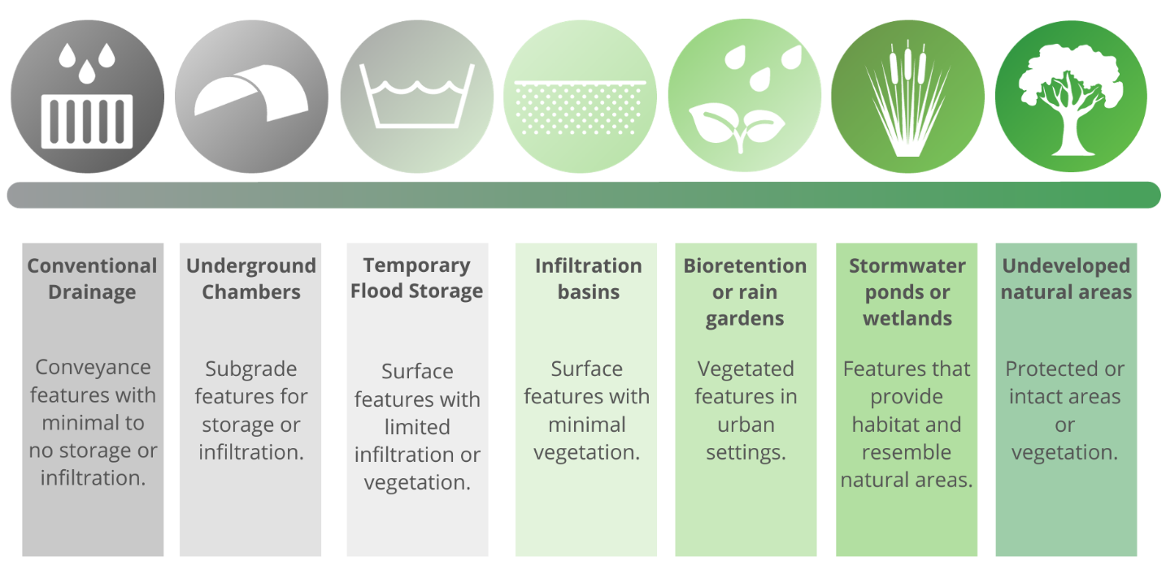
The PCRs prioritize implementation of green stormwater management strategies over traditional gray strategies. The County is mandated by the Central Coast Water Board to limit the use of gray stormwater management strategies where green strategies are feasible and achievable.

How this manual relates to other requirements
Several State and local policies dictate the volume of stormwater that must be treated and detained or retained onsite in San Luis Obispo County (i.e., PCRs, Flood Control Requirements, project conditions of approval). Depending on the requirements or policy, different stormwater management strategies and retention volume criteria may be required for the site design.
At the outset of the development project design process, the requirements of each policy indicated in Figure 2 should be carefully evaluated for their applicability to the proposed project. Multiple standards and submittals may be required based upon project scope and location. A pre-application meeting, conducted through the Department of Planning and Building that includes other department stakeholders is strongly encouraged for large, phased, or multi-use projects that must comply with multiple standards.
This guidebook specifically addresses strategies to comply with the Regional Post-Construction Stormwater Requirements. Depending on site design and applicable requirements, compliance with the Regional Post-Construction Requirements may partially satisfy local drainage and flood control requirements, and fully satisfy the post-construction standards of the State Construction Stormwater General Permit Order 2022-0057-DWQ, adopted September 8, 2022. However, in most cases additional retention or detention will be required to satisfy local drainage and flood control requirements.

Figure 2: Policies dictating post-construction stormwater runoff control standards
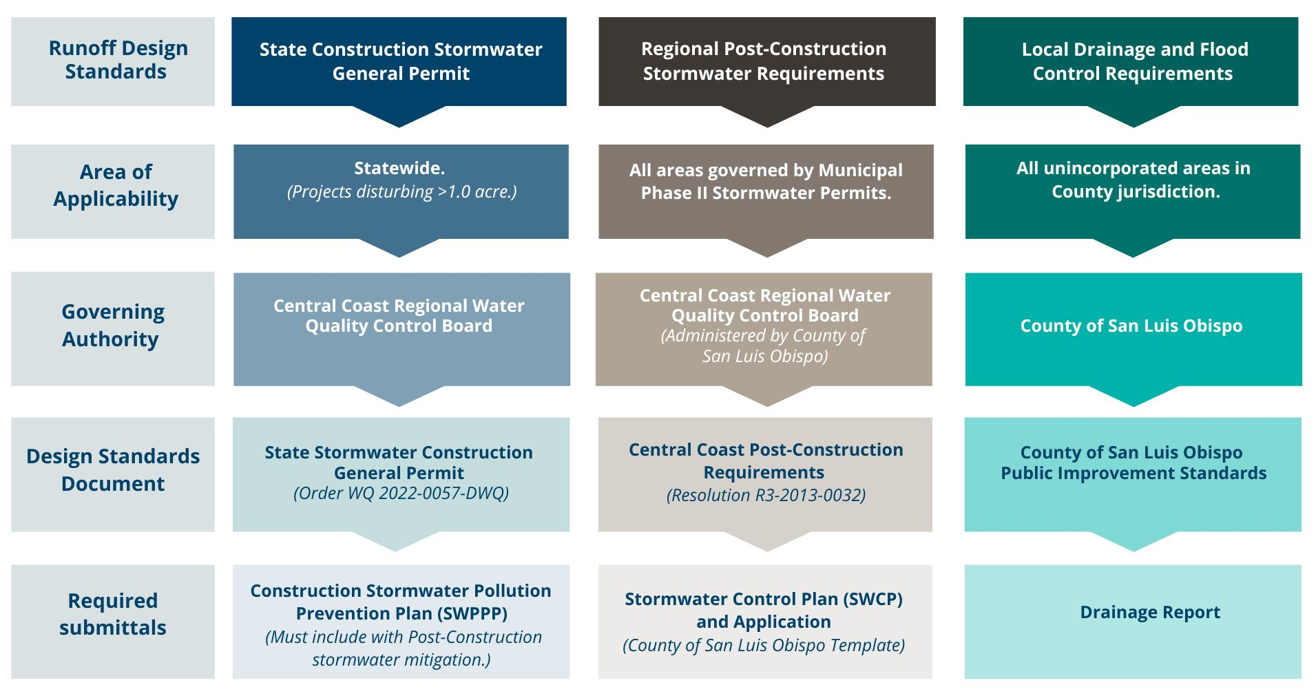

Project Triggers
The location and scope of a project will determine whether the PCRs must be applied to the project, and which Performance Requirements (PR) must be met. Project specifications such as the amount of impervious area created/replaced, the total area of soil disturbance, and applicable Watershed Management Zone (WMZ) must be determined early in the planning stages to begin evaluation of PCR applicability.

Geographic Areas
The County of San Luis Obispo applies the PCRs to all areas covered by the County’s Phase II Municipal Separate Storm Sewer Permit (MS4 Areas). This includes many of the County’s unincorporated communities, census designated places (CDPs), and urban reserve areas located near the outskirts of incorporated cities. The precise boundaries of the County’s MS4 Area are subject to change periodically due to annexations into the incorporated cities. Development projects located within any of the County’s incorporated cities are also subject to the PCRs. Development review, permitting, and PCR compliance are administered by the cities, not the County, within incorporated city limits.
Additionally, certain requirements of the PCRs vary depending upon the WMZ a project is located in. The applicable WMZ should be determined early in the project planning stages. WMZ boundaries were determined by the Central Coast Water Board based on key watershed processes and receiving water types, and the County does not have authority to modify or approve exceptions to the designated WMZs.
The County’s Department of Planning and Building hosts an online GIS web mapping application, which is the preferred method for determining if a project is in an MS4 Area and the applicable WMZ. Instructions for utilizing this tool are provided in Appendix A.

Previously vested projects
In rare circumstances, a project may have received approval and vesting prior to the effective date of the PCR policies outlined in Table 1. To qualify as a previously vested project, the project’s vesting tentative subdivision map must have been deemed complete and received first discretionary approval of project design prior to March 6th, 2014. The approved designs must show drainage, flood control and stormwater conveyance infrastructure that comply with the prior policies. Additionally, the project Conditions of Approval (via Notice of Final Action) must not indicate that compliance with LID or Post-Construction stormwater standards were required at the time of approval. A Notice of Final Action letter should reflect this project information. Copies of these documents must be provided as part of the construction permit application. A change to a previously approved and vested project may require additional Conditions of Approval and require compliance with the PCRs.
Projects that were vested prior to the effective date of the PCRs are not exempted from compliance with the State Construction Stormwater General Permit Order 2022-0057-DWQ which also contains post-construction stormwater mitigation requirements. There are no provisions in the State Construction Stormwater General Permit that offer a similar vesting exemption.

Project triggers and exemptions
The PCRs categorize construction activities and development projects in the MS4 Area as either “Unregulated” or “Regulated” based on specific project characteristics. Determining the project’s regulatory status is a fundamental step of the construction permit application process. Additionally, there are several compliance strategies available to regulated projects that are unable to achieve full compliance with the PCRs.

Unregulated projects
While determination of PCR compliance is typically based on new construction project impervious area, a limited scope of projects are designated ‘unregulated’ by the Central Coast Water Board. Applicants should closely review the unregulated project criteria in Table 3. Construction permit applications for unregulated projects are required to include the County’s Post-Construction Stormwater Waiver Request Form and justification that ensures compliance with unregulated project conditions. This form documents project information and allows the County to verify and confirm that the project is unregulated per the PCRs.
Table 3: Unregulated project criteria.
Unregulated Project Criteria
Unregulated project criteria are established by Central Coast Regional Water Quality Control Board Resolution R3-2013-0032, Attachment 1.
Road and Parking Lot maintenance
- Road surface repair including slurry sealing, fog sealing, and pothole and square cut patching
- Overlaying existing asphalt or concrete pavement with asphalt or concrete without expanding the area of coverage
- Shoulder grading
- Cleaning, repairing, maintaining, reshaping, or re-grading drainage systems
- Crack sealing
- Resurfacing with in-kind material without expanding the road or parking lot
- Practices to maintain original line and grade, hydraulic capacity, and overall footprint of the road or parking lot
- Repair or reconstruction of the road because of slope failures, natural disasters, acts of God or other man-made disaster
Sidewalk and bicycle path lane projects, where no other impervious surfaces are created or replaced, built to direct stormwater runoff to adjacent vegetated areas
Trails and pathways, where no other impervious surfaces are replaced or created, and built to direct stormwater runoff to adjacent vegetated areas
Underground utility projects that replace the ground surface with in-kind material or materials with similar runoff characteristics
Curb and gutter improvement or replacement projects that are not part of any additional creation or replacement of impervious surface area (e.g., sidewalks, roadway)
Second-story additions that do not increase the building footprint
Raised (not built directly on the ground) decks, stairs, or walkways designed with spaces to allow for water drainage
Photovoltaic systems installed on/over existing roof or other impervious surfaces, and panels located over pervious surfaces with well-maintained grass or vegetated groundcover, or panel arrays with a buffer strip at the most down gradient row of panels
Temporary structures (in place for less than six (6) months)
Electrical and utility vaults, sewer and water lift stations, backflows and other utility devices
Above-ground fuel storage tanks and fuel farms with spill containment system

It is important to note that a project can be waivable only if it consists of listed items. A development project may include a combination of several elements, both regulated and unregulated. If the scope of work includes more than the listed criteria of the waivable items indicated, then the project is not fully waivable, and cannot be considered unregulated.

Accessory Dwelling Units and Accessory Structures
California government code requires that permit applications for an accessory dwelling unit (ADU) or junior accessory dwelling unit (JADU) shall be considered and approved ministerially without discretionary review or hearing. Construction of an ADU or JADU does not modify the zoning of the site to multi-family residential, and the stormwater and construction standards for multi-family residential construction do not apply. The County will apply the PCRs to projects constructing ADUs and JADUS as they are written for detached single-family homes.
Additionally, parcels zoned for single-family residential use are authorized to construct residential accessory structures (barns, sheds, detached garages, etc.) consistent with County land use and building codes. Construction of these structures is dependent upon single-family residential zoning, and the PCR triggers and requirements identified for single-family home projects will be applied.

Technical Infeasibility
The PCRs provide a mechanism for the County to approve claims of technical infeasibility for onsite compliance with select performance requirements. County approval of technical infeasibility does not waive the requirement for applicants to provide alternative or off-site compliance within the same watershed as the regulated project. Applicants will be required to meet all of the PCR criteria associated with technical infeasibility.
The County will require submittal of an opportunities and constraints map (per the PCRs) to demonstrate the criteria are met for a technical infeasibility finding. Additional detail about the criteria for technical infeasibility is provided in Chapter 4. Applicants are encouraged to thoroughly review the specific criteria associated with technical infeasibility determinations in Resolution R3-2013-00032.

Urban Sustainability Areas & Regional Watershed Plans
The PCRs afford limited alternative compliance options for projects located within approved Urban Sustainability Areas (USAs) or areas subject to Regional Watershed Plans. The County has not developed plans for USAs or regional watershed plans that would allow applicants to exercise these alternatives. Due to the vast, variable, and discontinuous coverage of the County’s MS4 Permit Areas, the County does not plan to pursue a Regional Watershed Plan or USA designations for the purpose of facilitating alternative compliance with the PCRs.

Site Determination
In the context of PCR compliance, the “project site” includes all areas of development, including both onsite improvements and public improvements within the public right of way. Onsite improvements include all structural and nonstructural development planned within the boundaries of privately owned property. Public improvements associated with the project that may be constructed in the public right-of-way may include new roads, road widening, utility installation, or other improvements associated with the project. The development may require installation of structural SCMs on private property, in the public right-of-way, or on properties held in common ownership. Public improvements that are required as a condition of the project, but not contiguous to the rest of the project site, must demonstrate PCR compliance and may be considered a separate project.

Impervious surfaces, surface types
Redevelopment and new construction projects typically incorporate several types of hardened surfaces. Such alteration of a landscape from natural to hardened inherently changes the ratio of stormwater that is either infiltrated or transformed into stormwater runoff from the ratio associated with predevelopment conditions. The magnitude of impacts associated with post-project stormwater runoff generally increase as the project’s impervious surface area increases. This section further outlines types of surfaces, and which surface modifications are regulated by the PCRs.

Impervious surfaces, calculations
Impervious surfaces include any hard, non-vegetated surface areas that prevent or significantly limit the entry of water into the soil mantle, as would have occurred under natural conditions prior to development. Common impervious surfaces include roof tops, walkways, patios, driveways, parking lots or storage areas, and concrete or asphalt paving.
Many projects require repair or replacement of existing impervious surfaces as a component of development. Generally, construction activities that affect impervious surfaces but do not involve removal and/or replacement of the base course or result in a change in grade, are considered repairs. These repaired areas are not included in the regulated impervious surface area calculations. Construction activity that removes an impervious surface and underlying base course (down to native soils) is considered impervious surface replacement and is regulated by the PCRs.
Precise calculation of new, replaced, repaired, and removed impervious surface areas is essential to determine which Performance Requirements are applicable to the project. New and replaced impervious surface areas are the most important factors in making this determination. To determine replaced impervious surface area, a drawing of the existing, pre-project impervious areas should be placed as an overlay on the proposed site plan.

The County considers the following surfaces impervious for the purpose of calculating surface areas that apply to the Performance Requirement thresholds:
- Roofs, concrete, asphalt, grouted pavers.
- Bricks or solid pavers
- Grouted rock.
- Decomposed granite with binder.
- Dense graded aggregate or dense-graded road base (e.g. Class II, red rock).

Figure 3 lists each impervious surface category pertinent to determining the applicable Performance Requirements. The total area of each of these surface modifications should be determined before beginning impervious area calculations. This information is required to complete permit applications as detailed further in Chapter 3.

Figure 3: Impervious surface categories for determining project performance requirements.
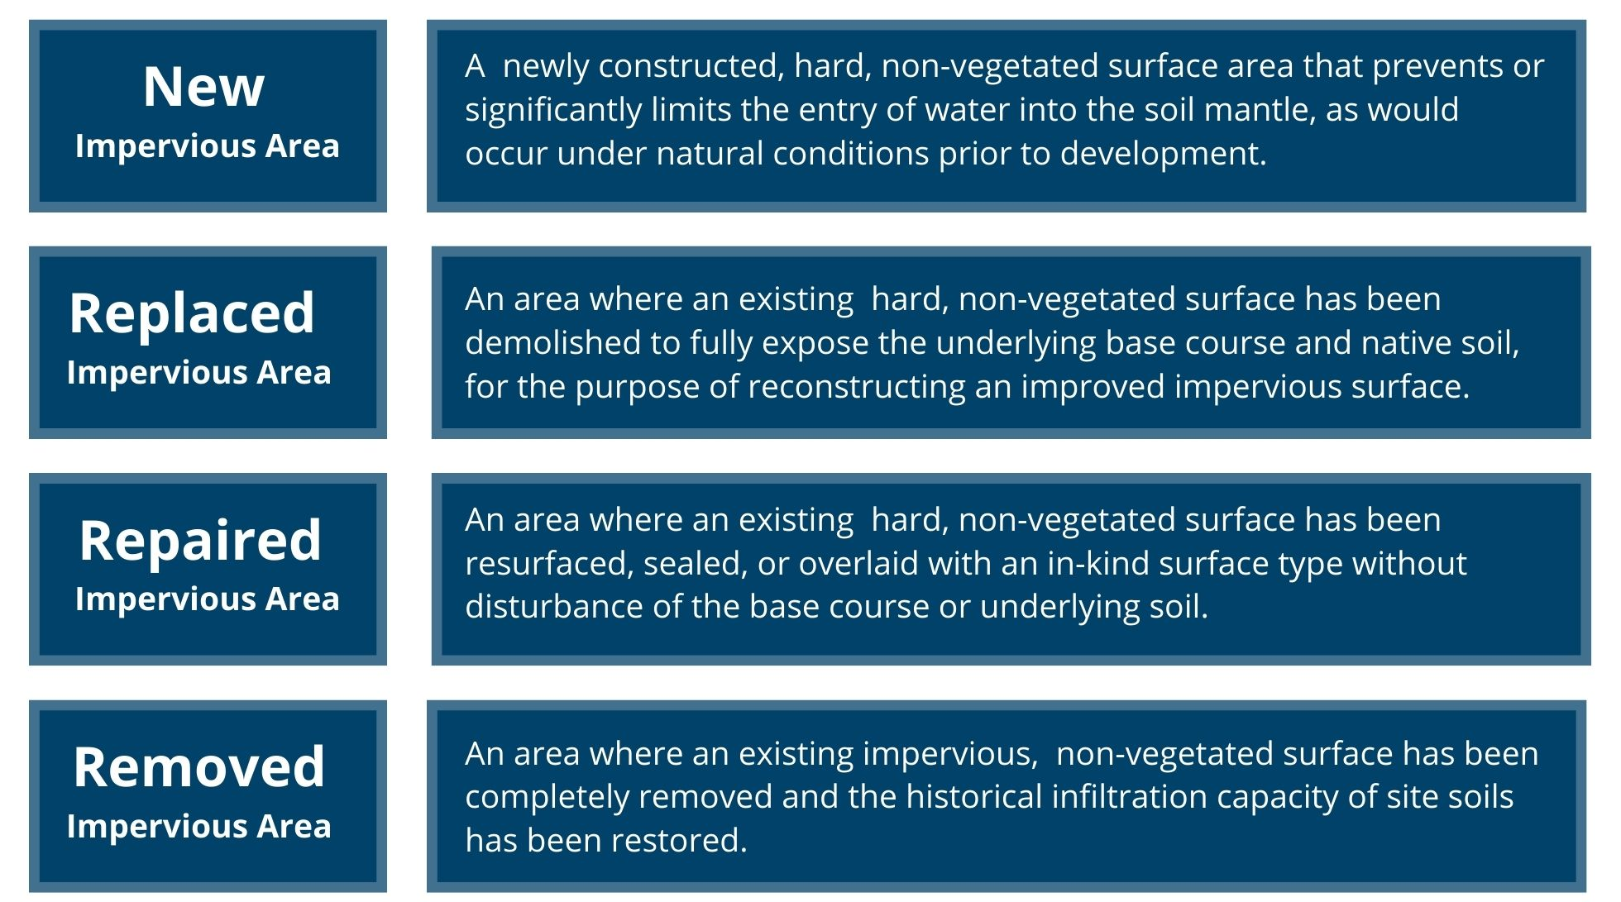

Applicants should begin by calculating the Total New and Replaced Impervious Area. In new construction projects on vacant properties, there are typically no replaced impervious areas.

Equation 1: Total new and replaced impervious area
In some limited cases, a reduction in total imperviousness from the pre-project to post- project site condition may reduce the net impervious area. The reduced impervious area credit is only applicable where there is a net pre-project to post-project reduction in impervious area.

Equation 2: Net impervious area
Example project calculations are included in Figures 6 and 7 at the end of this chapter.

Engineered pervious surfaces
Inclusion of engineered pervious surfaces in new development plans is common throughout San Luis Obispo County. Examples of engineered pervious surfaces may include turf block, artificial turf, unit pavers with permeable joints, pervious asphalt, porous/pervious concrete, or open-graded gravel. Incorporation of engineered pervious and natural pervious surfaces into new and redevelopment projects can reduce the performance requirements applied to the project. Chapter 6 includes additional information on how to incorporate engineered pervious surfaces into project calculations.

Performance Requirements Summarized
The PCRs utilize a group of Performance Requirements for new and redevelopment projects that invoke stormwater management strategies that preserve key watershed processes. This section briefly summarizes each Performance Requirement and its related implementation requirements, including the types of projects subject to the Performance Requirements.

Figure 4 presents a flow chart for determining which Performance Requirements apply to regulated projects. The performance requirements and applicable regulated projects are also summarized in Table 4 and detailed more thoroughly in the following sections.

Figure 4: Applicable performance requirements determination chart
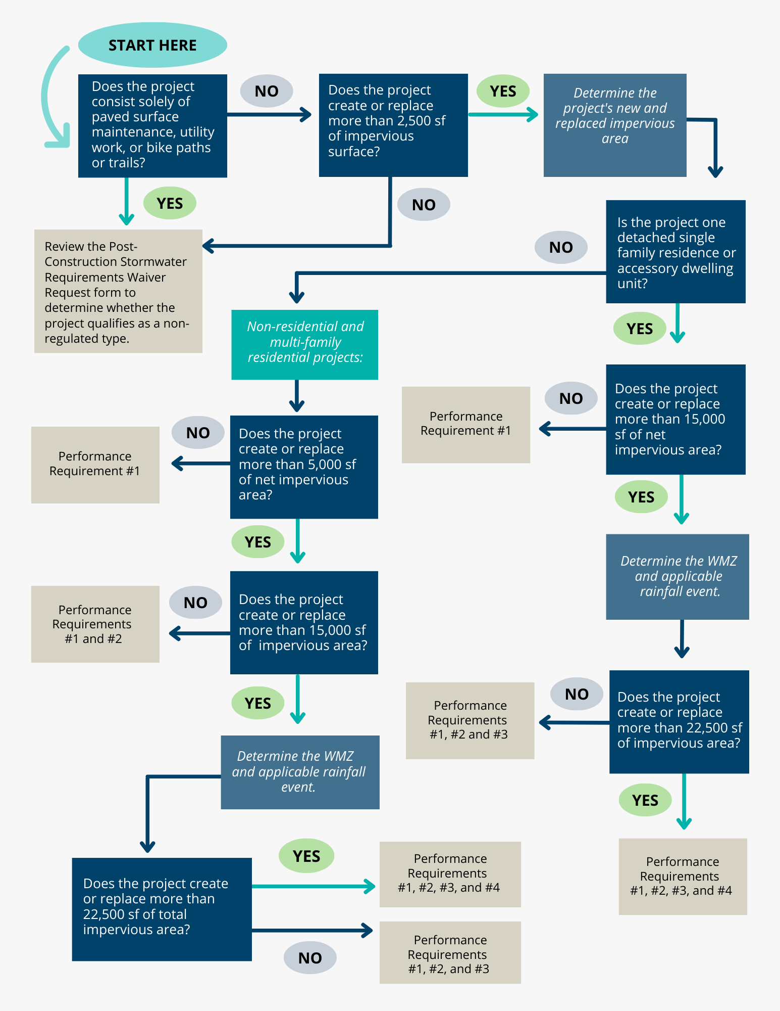
Table 4: Summary of post-construction performance requirements
Central Coast Post-Construction Stormwater Performance Requirements
Type of Project | Requirements
Tier 1: Projects, including one single-family home that is not part of a larger plan of development, that create or replace 2,500 sf or more of impervious surface. | Implement Performance Requirement #1  LID Measures:  Limit disturbance of natural drainage features.  Limit clearing, grading, and soil compaction.  Minimize impervious surfaces.  Incorporate at least one (1) runoff reduction measure.
Tier 2: Projects, other than one single-family home that is not part of a larger plan of development, that create or replace 5,000 sf or more net impervious surface.* | Performance Requirement 1, plus:  Treat runoff with an approved and appropriately sized LID treatment system prior to discharge on or from the site.
Tier 3 Projects, other than single-family homes, that create or replace 15,000 sf or more of impervious surface.  Single-family homes that create or replace 15,000 sf or more net impervious surface.* | Performance Requirements 1 & 2, plus:  Prevent offsite discharge from events up to the 95th percentile rainfall event using Stormwater Control Measures.
Tier 4 Projects that create or replace 22,500 sf of impervious surface. | Performance Requirements 1, 2, & 3, plus:  Control peak flows to not exceed pre-project flows for the 2-year through 10-year events.
* Net impervious surface equals new plus replaced impervious area, minus the total pre-project-to-post project reduction in impervious area (if any).

Performance Requirement #1 (PR#1): Site Design and Runoff Reduction
This requirement applies to projects that create and/or replace > 2,500 square feet of impervious surface and focuses on the LID design concept of mimicking predevelopment hydrology. Projects must incorporate site design and runoff reduction measures where feasible. Site design measures are the best opportunity to implement management strategies that maintain the soil and vegetation regime, which in turn support other strategies for flow control and water quality treatment.
While detailed plans are not required for demonstrating compliance, applicants must indicate that the specific measures will be incorporated into the project site design where feasible. The location of site design elements that support PR#1 compliance should be clearly labeled on grading or utility plan sheets and detailed in the SWCP (for applicable projects.) Some examples of PR#1 site design strategies are provided in Table 5.

Table 5: Examples of PR#1 site design strategies
Strategy: | Implementation:
Limit disturbance of creeks and natural drainage features. | - Indicate on the plans where the project will avoid wetlands and waterways. This may include agency mandated buffers or development setbacks.  - Incorporate design elements that avoid routing runoff to direct waterway outfalls. Indicate that an alternative to direct outfall was selected.  - Indicate where flatwork, abutments, or foundations are deliberately set back from creek banks or natural drainage features.
Minimize compaction of highly permeable soils. | - Indicate areas on the plans that will be protected from grading, clearing, and/or over excavation. This may include landscaped or unpaved areas.
Limit clearing and grading of native vegetation. | - Indicate on site plans where existing native trees will be protected in place.  - Indicate any locations where existing native plants will be protected. This may include protection by mandatory setbacks (i.e. near sensitive features, sensitive plants, wetlands, or waterways.)
Minimize impervious surfaces and concentrate improvements on least-sensitive portions of the site. | - Identify locations that will not be developed due to sensitive resources or open space requirements.  - Indicate where redevelopment will occur in the footprint of existing impervious surfaces.
Additionally, applicants must incorporate at least one (1) runoff reduction measure into the site design. Approved runoff reduction measures are summarized in Figure 5. The County’s guidelines for the volume of runoff addressed by these runoff reduction measures are indicated in Table 6.
Figure 5: Runoff reduction measures, PR#1
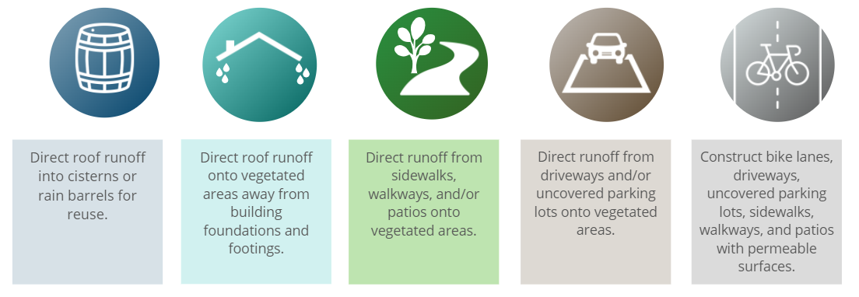
Table 6: Runoff reduction strategy volume guidelines.
Runoff Reduction Strategy | Guidelines for Runoff Volume
Direct roof runoff into cisterns or rain barrels for reuse. | Minimum 100-gallon volume for collection.
Direct roof runoff to vegetated areas away from foundations and footings. | Minimum 10% of roof area directed to vegetated areas.
Direct runoff from sidewalks, walkways and/or patios onto vegetated areas. | Minimum 10% of flatwork area drainage directed to vegetated areas.
Direct runoff from driveways and/or parking lots onto vegetated areas. | Minimum 10% of flatwork area drainage directed to vegetated areas.
Construct flatwork with engineered pervious/permeable surfaces. | Minimum 10% of flatwork area constructed with permeable surfaces.

Performance Requirement #2 (PR#2): Water Quality Treatment
The Water Quality Treatment Performance Requirement (PR#2) applies to projects that create and/or replace > 5,000 square feet of Net Impervious Area, and to single-family residences that create and/or replace > 15,000 square feet of Net Impervious Area. A SWCP is required for all regulated projects subject to PR#2.
Regulated projects subject to PR#2 must treat a defined minimum volume or flow rate of runoff using onsite measures. This performance requirement addresses post-construction pollutant loading through treatment measures that emphasize LID (harvesting and re-use, infiltration, and evapotranspiration) and biofiltration over non-retention based or flow-based treatment approaches. Allowable onsite measures are listed in the order of preference (highest to lowest):
1. Low Impact Development
2. Biofiltration Treatment Systems
3. Non-Retention Based Treatment Systems
Biofiltration treatment is prioritized over non-retention based treatment systems due to the potential for the biofiltration system to provide infiltration/retention and more closely replicate watershed processes (evapotranspiration, chemical and biological transformations) than flow-through (non-retention) measures. Table 7 summarizes the water quality treatment design criteria associated with PR#2.

Table 7: PR#2 design criteria
Water Quality Treatment Strategy | Design Criteria
LID Treatment System:  Harvesting and use, at-grade infiltration, evapotranspiration, bioretention (without an underdrain). | Retain stormwater runoff from the 85th percentile 24-hour storm event. Runoff volume based on local rainfall data.
Biofiltration Treatment System:  Bioretention features with a raised underdrain or similar facilities with an equivalent effectiveness to meet the specified design criteria. | Design rain event of 0.2 in/hr intensity or 2x 85th percentile hourly rainfall intensity.  Additional design criteria:  - Maximum surface loading rate 5 in/hr.  - Surface reservoir depth of 6”-12”.  - Minimum planting medium depth 24”.  - Proper plant selection to sustain 50% vegetated cover/survivorship.  - Subsurface gravel layer minimum depth 12”.  - Underdrain placement at top of gravel layer.  - No compaction of soils beneath structure.  - Liners only authorized for sidewalls where required.
Non‐Retention Based Treatment Systems:  Lined bioretention, flow‐through planters, high rate tree well filters or media filters. | Volumetric hydraulic design to 85th percentile 24-hour storm event.  Flow hydraulic design basis of 0.2 in/hr intensity.  or 2x 85th percentile hourly rainfall intensity.

Performance Requirement #3 (PR#3): Runoff Retention
The Onsite Runoff Retention Performance Requirement (PR#3) applies to projects that create and/or replace > 15,000 square feet of impervious surface, and to single-family residences that create and/or replace > 15,000 square feet of Net Impervious Area. A SWCP is required for all regulated projects subject to PR#3.
Regulated projects subject to PR#3 must meet PR#1 and PR#2 requirements and additionally retain runoff from a designated design storm volume. The required retention volumes and method depend on the Watershed Management Zone (WMZ) in which the project is located, with some WMZs not requiring runoff retention. The PCRs Resolution R3-2013-0032 should be consulted to determine which runoff retention requirements apply in the project’s WMZ. A decentralized stormwater management approach is fundamental to demonstrating compliance with PR#3.
Regulated projects must demonstrate that the use of Site Design and Runoff Reduction measures have been maximized to the extent feasible and indicate which LID development standards are utilized to meet PR#3 requirements. The development standards include the following:
- Site Assessment Measures – identify opportunities and constraints to implement LID,
- Site Design Measures – optimize site design measures and strategies from PR#1 and augment with additional measures,
- Delineation of discrete Drainage Management Areas (DMAs), and
- Use of undisturbed natural landscaped areas as self‐treating or self‐retaining areas.
Resources for identifying and appropriately demonstrating site opportunities and constraints are provided in Appendix B. Once site design measures, self‐treating areas and self‐retaining areas have been maximized to the extent feasible, structural Stormwater Control Measures (SCMs) may be incorporated to retain runoff.
SCMs can be sized using one of three methodologies:
- Continuous simulation hydrologic modeling, calibrated to local conditions;
- The simple method (single event‐based); or
- The routing method (single event‐based).
The simple method sizes the structural SCM with a volume equal to the runoff volume produced by the design storm. The routing method uses iterative calculations routing the design storm hydrograph through the facility to account for infiltration that occurs simultaneously with inflow, which results in a smaller facility. Sizing guidance for the simple method and the routing method are provided in Chapter 6.
Santa Barbara County developed a “Stormwater Control Measures Sizing Calculator” Excel Workbook that uses the routing method. The outputs from the calculator are authorized for Stormwater Control Plan submittals in San Luis Obispo County. Downloads and user instructions are available on the Santa Barbara County website. A hyperlink is included in Appendix A.
The PCRs include allowances for technical infeasibility adjustments and off-site mitigation for sites that are significantly constrained in their ability to comply with PR#3. Additional information is included in Chapter 4.

Performance Requirement #4 (PR#4): Peak Management
Regulated projects that create and/or replace >22,500 square feet of impervious surface (collectively over the entire project site) are subject to PR#4. Projects subject to PR#4 must also meet PR#1, PR#2 and PR#3 requirements. A SWCP is required for all regulated projects subject to PR#4.
Regulated projects subject to PR#4 must ensure that post-development peak flows, discharged from the site, do not exceed pre-project peak flows for the 2- through 10-year storm events. The pre-project condition refers to the runoff conditions that exist onsite immediately before the development project begins. A site hydrology report must effectively demonstrate that post-development stormwater peak flows from the site do not exceed pre-project peak flows. Additional discharge constraints may also apply to the project such as those mandated by the San Luis Obispo County Public Improvement Standards.
Additional information on the required calculations and model outputs for submittal is provided in Chapter 6.

Performance Requirement #5 (PR#5) Special Circumstances
This Performance Requirement may modify applicability of the PCRs for specific conditions, such as highly altered channels and intermediate flow control facilities. The County may consider and designate individual projects as subject to PR#5 based on site and receiving water conditions. The applicability of PR#5 is significantly limited in San Luis Obispo County due to the scarcity of highly altered channels and intermediate flow control facilities.
Applicants who believe that their project meets the criteria for PR#5 are strongly encouraged to thoroughly review the conditions of PR#5 and request a pre-application meeting with the County prior to initial plan submittal. Additional processing time and review fees may apply.

Example Project #1:
The following example demonstrates how to correctly determine Total New and Replaced and Net Impervious Area. Figure 6 demonstrates new, replaced, and removed impervious surface types and how to properly calculate the net impervious area.

Figure 6: Example project #1, impervious area metrics
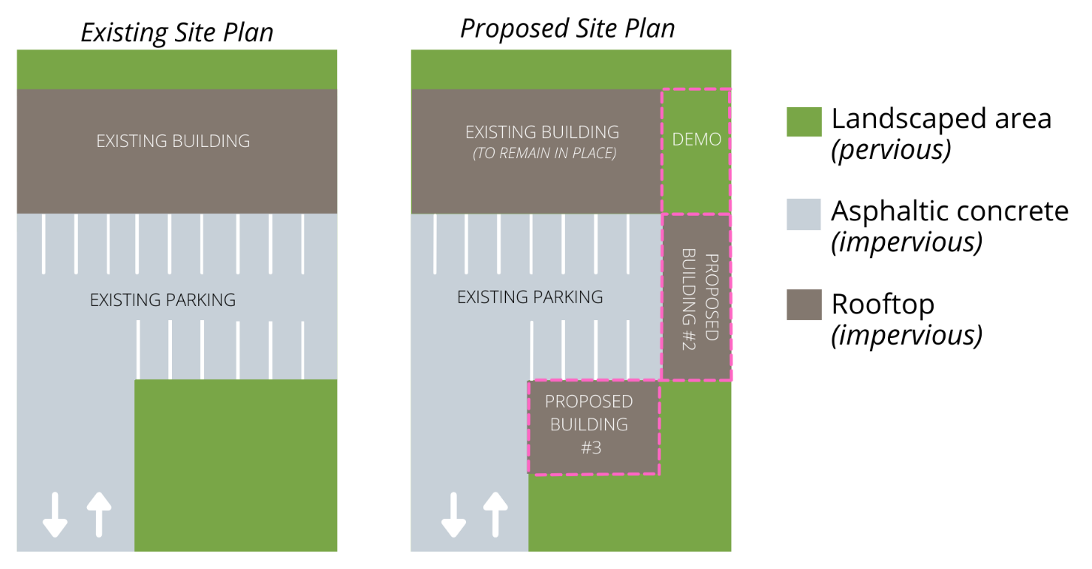

Existing Site Plan |  |  | Proposed Site Plan
Surface | Area |  | Surface | Area
Existing Pervious (landscaping) | 12,780 sf |  | New Impervious  (landscaping to proposed building #3) | 3,340 sf
Existing Impervious  (building, parking) | 30,780 sf |  | Removed Impervious  (building #1 to landscaping) | 2,360 sf
 |  |  | Replaced Impervious  (parking to proposed building#2) | 3,140 sf
Calculating New and Replaced Impervious Area:
New Impervious + Replaced Impervious = Total New and Replaced Impervious Area
3,340 sf + 3,140 sf = 6,480 sf

Impervious Area Credit (not applicable):
Pre-project net impervious: 30,780 sf
Post-project net impervious: 34,900 sf

The overall increase in site impervious area (+4,120 sf) does not allow credit for reduced impervious area. The new and replaced impervious area, as well as the net impervious area for determining PCR compliance is 6,480 sf. This project is subject to PR#1 and PR#2.

Example Project #2:
Figure 7, demonstrates impervious surface calculations and how the reduced impervious area credit is applied.
Figure 7: Example project #2, net impervious area reduction example
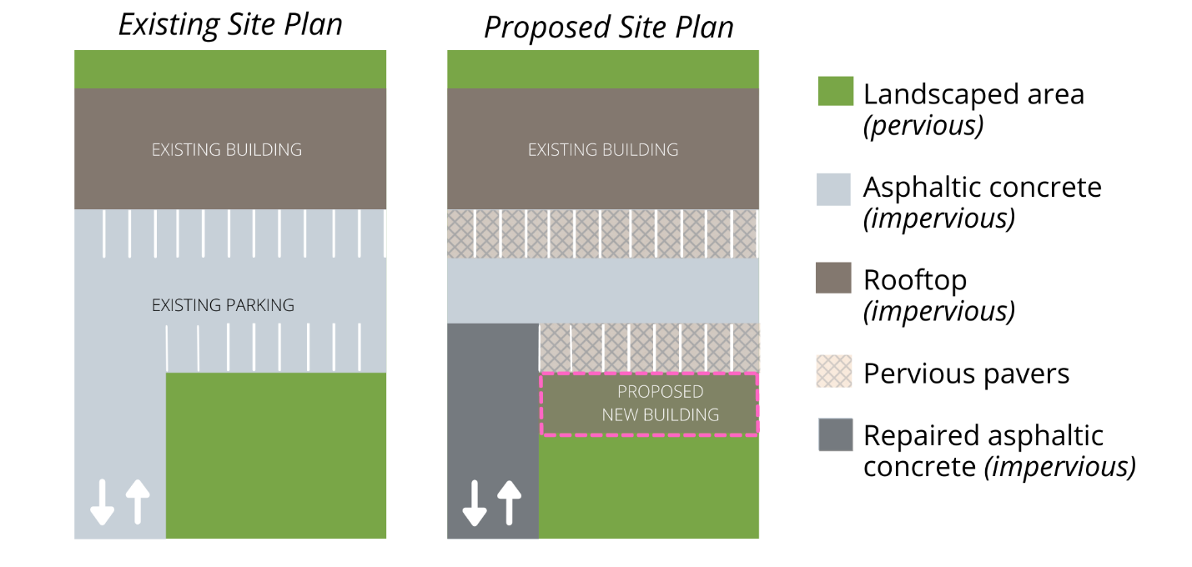
Existing Site |  |  | Proposed Site
Surface | Area |  | Surface | Area
Existing Pervious (landscaping) | 12,780 sf |  | New Impervious  (landscaping to proposed building) | 3,830 sf
Existing Impervious  (building, parking) | 30,780 sf |  | Removed Impervious  (paved parking to pervious pavers) | 7,430 sf
 |  |  | Replaced Impervious | 0 sf
 |  |  | Repaired Impervious  (seal coating existing driveway) | 5,580 sf

Calculating New and Replaced Impervious Area:
New Impervious + Replaced Impervious = Total New and Replaced Impervious Area
3,830 sf + 0 sf = 3,830 sf

Impervious Area Credit:
Pre project impervious area: 30,780 sf
Post project impervious area: 27,180 sf
(Pre Project Impervious Area ) – (Post Project Impervious Area) = Reduced Impervious Area Credit
(30,780 sf) – (27,180 sf) = 3,600 sf

The overall decrease in site impervious area (-3,600 sf) allows for credit for reduced impervious area.
(New + Replaced Impervious) – (Reduced Impervious Area Credit) = Net Impervious Area
(3,830 sf) – (3,600 sf) = 230 sf

The New and Replaced Impervious Area for determining PCR compliance is 3,830 sf. This project is subject to PR#1 due to the total new and replaced impervious surface exceeding 2,500sf. The Net Impervious Area for determining PR#2 compliance is 230sf. The project is not subject to PR#2.

Submittal Process Overview
The County has integrated post-construction stormwater management into the development review process to comply with regional, state, and federal regulatory requirements. This chapter outlines the County’s development review process and gives instructions for how to prepare permit applications for new development and redevelopment projects.

Timeline for Submittals and Required Documents
New and redevelopment projects may be required to submit Stormwater Control Plans (SWCP) and Stormwater Control Plan Applications (SWCP Apps) both prior to land use permit and/or tentative subdivision approval and again prior to issuance of construction permits. These documents convey critical project specific information to the County, verify construction feasibility, and are to be certified by an appropriately licensed individual. SWCPs and SWCP Apps submitted during land use permit or tentative subdivision review and approval are considered preliminary documents to demonstrate PCR feasibility and site features and are referenced for verifying conformance during construction permitting. SWCPs and SWCP Apps submitted with construction permit applications are considered final documentation and should be fully detailed and complete.

Preliminary Stormwater Control Plans, Land Use and/or Tentative Subdivision Approval
The purpose of preliminary SWCP Apps and SWCPs is to ensure that the proposed site design will be able to integrate necessary LID measures and structures to reduce post-construction stormwater impacts and meet all of the applicable requirements of the PCRs. At the land use permit and/or tentative subdivision approval stage, applicants must provide sufficiently detailed documents that demonstrate the project’s ability to fully comply with the objectives in Figure 8. This includes delineation of DMAs for the entire project, estimated runoff volumes generated in each DMA, and estimated square footage, treatment volume, and retention volume addressed by each structural SCM.
Figure 8: Preliminary SWCP objectives
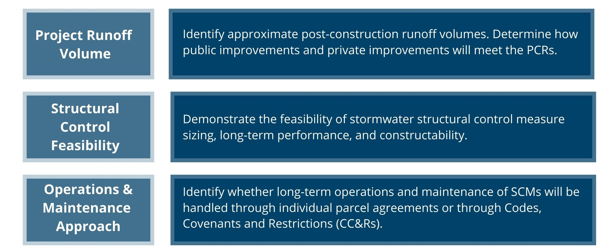
For subdivisions, the County strongly encourages applicants to prepare preliminary SWCPs that address the ‘full build-out’ runoff volume resulting from all lots as well as all public improvements. SWCPs that address only the runoff volume associated with public improvements associated with a subdivision will necessitate that the County impose the full extent of the tract’s PCR requirements on each parcel in the subdivision as they apply for individual construction permits. The preliminary SWCP should also indicate whether the project will enter into a new individual owner stormwater operations and maintenance agreement or incorporate operations and maintenance provisions into CC&Rs or an existing agreement.
County staff will review the preliminary SWCP and SWCP App and request additional information or clarification through an information hold if necessary. Applicants are encouraged to provide detailed calculations and specifications wherever possible in the preliminary SWCP. Project conditions of approval typically require submittal of a final SWCP and SWCP App at the time of application for construction permits, and completion and execution of an operations and maintenance agreement for stormwater infrastructure.
While the square footages, feature layouts, and surface types may fluctuate between the preliminary and final SWCP, the final SWCP should not deviate substantially from the preliminary SWCP unless significant site constraints are revealed by subsequent technical investigations. Detailed information about the contents of these submittals is provided in Chapter 7.

Final Stormwater Control Plans, Construction Permit Application
Final SWCPs and SWCP Apps are required submittals with applications for grading and construction permits. These documents are not considered conceptual and should only be submitted to the County as fully completed, stamped, reports and plans. Submittal of incomplete documents extends and delays the plan review process.
In addition to the site plans, SWCP, and SWCP App, applicants should submit a complete soils and geotechnical report, results of any infiltration and/or percolation testing performed at the site, and a separate site drainage report. Information in these reports is cross-checked by the County to ensure feasibility and compliance of the proposed design. Applicants should also submit a draft Operations & Maintenance Agreement (O&M Agreement). Detailed procedures for compiling a draft O&M Agreement for post-construction stormwater features is provided in Chapter 9. Applicants are encouraged to reference the list of required plans and documents in Figure 9 when preparing their submittals.
Figure 9: Required submittals with final stormwater control plans
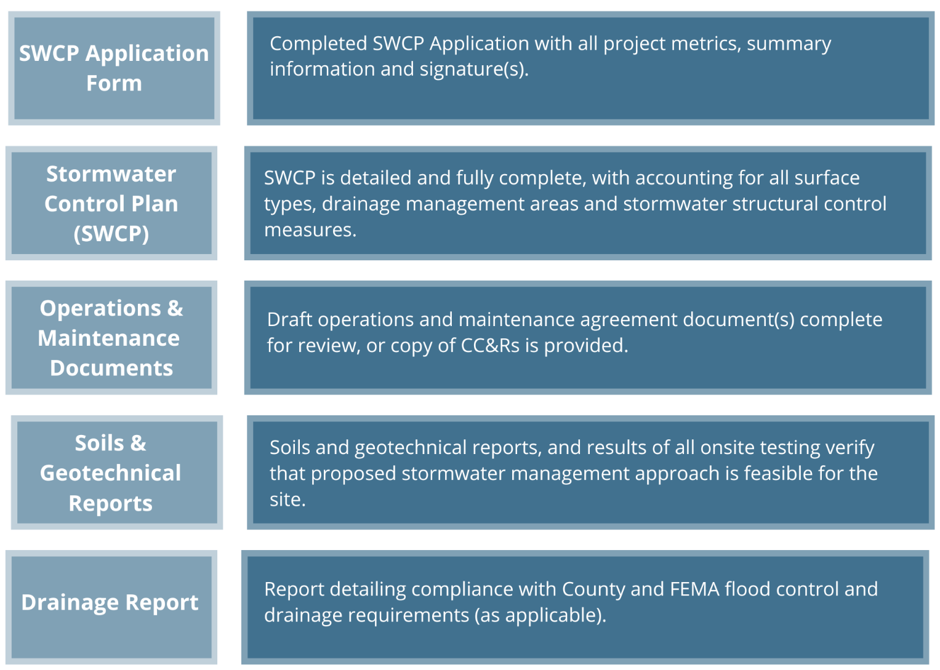
Project information included in the SWCP and SWCP App must be consistent with other application materials including plans and reports. Detailed information about the requirements for these submittals is provided in Chapter 7.

Additional Construction Permit Submittal Requirements
Projects with an area of disturbance greater than 1.0 acre are also required to submit a construction Stormwater Pollution Prevention Plan (SWPPP). The SWPPP should note that the project is designed to comply with the PCRs. The final version of the SWPPP should include appendices or attachments that incorporate copies of the SWCP, SWCP App, and an unofficial copy of the O&M Agreement. Beginning in September 2023, documentation of post-construction stormwater management measures is required as part of the permit registration documents for the Construction General Permit. Inclusion of the final post-construction stormwater documents as appendices can expedite Central Coast Water Board review of the project’s Notice of Termination (NOT).

Site Assessment
Effective stormwater management requires early and ongoing coordination among project owners, architects, landscape architects, geotechnical engineers, and civil engineers. Careful consideration of the initial site layout can significantly reduce the volume of stormwater that will need to be treated and infiltrated through structural stormwater control measures (SCMs). The site assessment phase occurs prior to developing the final project concept and site design and is intended to identify site-specific stormwater “opportunities” and “constraints” that can be utilized as a basis for designing a well-balanced project.

The site assessment process prioritizes two (2) important strategies:
- For new development projects, the goal is to “mimic the pre-development stormwater runoff characteristics of the undeveloped site” through early implementation of strategically placed low impact design features and structural Stormwater Control Measures (SCMs).
- For redevelopment projects, the goal is “to reduce and/or prevent further impacts to downstream and impaired waterways” through the implementation of strategically placed LID and structural SCMs.

Opportunities and Constraints Analysis
Early assessment allows the design team to identify and preserve areas of the project site that favor PCR compliance (opportunities), while prioritizing development to portions of the project site that do not (constraints). Minimizing disturbance and maximizing opportunities begins during the design phase by fitting the development into the terrain, as opposed to changing the terrain to fit the development.
Thoughtful site design can also reduce or eliminate the need for more expensive, complex stormwater treatment controls that are ‘force-fit’ into a project’s site plan late in the design process. An abbreviated list of opportunities and constraints is provided in Table 8. A comprehensive opportunities and constraints checklist with additional guidance is included in Appendix B. The County will require submittal of a detailed Opportunities and Constraints analysis as part of the justification for installation of underground structural SCMs or a Technical Infeasibility finding.

Table 8: Opportunities and constraints summary table.
Opportunities and Constraints
The following site characteristics should be considered as part of the project opportunities and constraints analysis.
Existing Vegetation
- Existing, high-quality vegetation and trees are identified. Site disturbance at these locations during construction can be prevented by protective fencing.
Survey and Site Topography:
- Integrate existing drainage patterns into the site design where possible. Prioritize existing, natural low-spots and sumps for infiltration and drainage features. Prioritize existing high spots for placement of structures or hardscapes, allowing runoff to naturally drain to low lying areas for treatment.
Soil Analysis:
- Prioritize LID and SCM placement where onsite soils have the highest potential for infiltration. Consider hardscape placement where soils discourage infiltration.
Geotechnical Analysis:
- Utilize information from soil borings and any geotechnical analysis to determine locations that are most suitable for infiltration (based on subsurface materials encountered) and locations with erosion hazards and landslide hazards that should be avoided.

Setbacks:
- Establish setbacks and buffer zones surrounding restricted and/or sensitive areas. Identify areas where SCMs cannot be constructed due to setback requirements. Examples include existing and proposed building foundations, municipal water wells, private water wells, septic systems, flood zones, easements, etc. (See Table 15 for additional setback information.)
- Determine the groundwater table elevation (including seasonally high and historically high) based on available historic data to ensure appropriate setbacks can be maintained.
Hydrologic Features:
- Identify onsite and offsite waterways and drainage infrastructure including locations where stormwater run-on may impact the site.
Pollutants of Concern:
- Identify areas where future or existing site operations could generate potential pollutants and locations where contaminated soil or historic pollution sources may be present.
Construction Footprint:
- Identify locations where existing vegetation or highly permeable soils can be protected from construction activity such stripping, over-excavation, compaction or stockpiling during construction.

Soil Classification
Soil types are highly variable across San Luis Obispo County with a wide range of characteristics and infiltration capabilities. Applicants are encouraged to undertake site specific soils investigations early in the planning and design process to confirm data and maps available from various public agencies. Site-specific soils and infiltration assessments provide key information on structural SCM siting and feasibility.

Hydrologic Soils Groups
Hydrologic soil groups at the project location must be identified by soil groups (A, B, C, or D) by a licensed Geotechnical Engineer, Geologist, or Civil Engineer. The hydrologic soil groups must be included in any SWCP.
The preliminary SWCP may solely rely on NRCS soils data if a site-specific soil evaluation has not been completed, except where underground infiltration features are proposed. A site-specific soil investigation report is required as supporting documentation for the final SWCP. The site-specific soil investigation should be utilized for design if the findings do not conform with the NRCS soils data.

Percolation Testing
The ‘percolation rate’ obtained from a percolation test is not equivalent to the ‘infiltration rate’ obtained from targeted infiltration testing methods such as single or double ring infiltrometer tests. While the percolation rate is related to the infiltration rate, percolation rates are greater than infiltration rates. Percolation testing measures both the downward progression and the lateral progression of water into the soil (i.e., the bottom surface area and the sidewalls), while an infiltration rate refers to the rate of water progressing downward into the soil (i.e., only the bottom surface).
The County generally does not consider raw percolation test results acceptable for sizing PR#3 or PR#4 SCMs, as the design is likely to assume infiltration rates unlikely to be achieved in situ over the extended post-construction period. Percolation rates can only be utilized in design if obtained via well-documented testing. The measured raw percolation rate must be converted to an acceptable estimate of the infiltration rate via the Porchet Method, with limited exceptions for specific SCM types. Additional information about calculating these conversions is detailed in Chapter 6.

Infiltration Rates and Soil Testing
Infiltration tests must be conducted in the field where full infiltration and direct infiltration SCMs are proposed to ensure that the measurements are representative of actual site conditions. It is recommended that these tests occur during the wet season to obtain more accurate results for design infiltration rates in potentially saturated soil conditions.
It is ultimately at the discretion of the project geotechnical professional to select and apply testing methods that are most suitable to address site-specific factors. There are inherent limits to which infiltration testing will reflect as-built and long-term project performance.
The degree of minimum required soil infiltration testing varies by the size of the project, the site’s soil types and conditions, anticipated SCMs, and the phase of project development.
All projects that include SCMs should anticipate performing at least three (3) soil borings to characterize site soils. Testing should position at least one (1) boring within the footprint of any proposed underground infiltration SCM. Soil borings are used to characterize site soils, support structural design, and support design infiltration rates throughout project site. Separate infiltration testing must be performed per the guidelines that follow.
Projects subject to PR#3 or PR#4 must perform at least three (3) infiltration tests, with at least one (1) test within the footprint of a proposed SCM to support design infiltration rate. Bioretention and biofiltration SCMs are exempt from this infiltration testing requirement if applying the HSG infiltration rates provided in Chapter 6.
If testing is not conducted during the planning phase (supporting the preliminary SWCP), testing will be required for the construction documents design phase (final SWCP), as outlined in Chapter 3.
Additional infiltration testing and soil characterization may be necessary prior to any application for construction permits. The following scenarios may necessitate additional testing for the final SWCP to ensure design suitability:
- Non-uniform soils across the project site.
- Relocation of infiltration based SCMs to locations where testing has not been conducted.
- Installation of SCMs at an elevation not previously characterized by soil borings or infiltration tests.
- Testing was not performed in locations where significant earthwork, fill import, or compaction could impact infiltration rates.
- Proposed use of underground/subsurface infiltration SCMs.

Design infiltration rates shall be established using methods that are appropriate for the proposed SCMs and should incorporate an appropriate factor of safety. Table 9 specifies soil testing criteria (in addition to site soil borings) and minimum factors of safety based upon the feature type proposed and soils testing performed.

Table 9: Infiltration testing methods and appropriate factors of safety for SCM design.
SCM Type | Test Method | Minimum Number of Tests | Minimum Factor of Safety
Bioretention | Percolation  (converted via Porchet Method) | 3 per site* | FS = 1
 | Infiltration  (Ring Infiltrometer) | 3 per site*
 | Hydrologic Soil Group (HSG) (standardized rates) | None required.
Surface Infiltration | Percolation  (converted via Porchet Method) | 3 per site* | FS = 2
 | Infiltration  (Ring Infiltrometer) | 3 per site*
 | Hydrologic Soil Group (HSG) (standardized rates) | None required.
Underground Infiltration  (infiltration trench, dry well, chamber infiltration system, etc.) | Percolation  (converted via Porchet Method, unless dry well) | 3 per site* | FS = 3**
 | Infiltration  (Ring Infiltrometer) | 3 per site*
 | Hydrologic Soil Group (HSG) (standardized rates) | HSG rates not allowed to be used in design of underground SCMs
* Minimum one (1) within SCM footprint.
** Where surface biofiltration is provided directly upstream of an underground infiltration SCM, a minimum factor of safety of 2 is permissible.
Additional guidelines for soil investigations and testing
- Testing must be conducted or overseen by a qualified, licensed professional.
- Testing should be conducted in the footprint of proposed infiltration SCMs.
- The elevation of tests should correspond to the elevation where infiltration will take place at the soil interface.
- Soil boring logs should extend at least 5-10 feet below the proposed bottom elevation of the planned SCM.
These guidelines may be reduced or increased at the discretion of the project professional and reviewing jurisdiction depending on the complexity and variability of the site.

Factors of Safety
Performance of infiltration SCMs is limited by the decline of infiltration rates over time, and applying an appropriate factor of safety to infiltration testing results is required. Infiltration rates typically decline between maintenance cycles as the feature’s surface becomes impaired with sediment in the infiltrative layer. The functional infiltration rate is often lower than the rate measured during design, necessitating that adequate conservatism is incorporated in the selection of design infiltration rates. Applicants should incorporate appropriate factors of safety specified in Table 9.

Depth to Groundwater
The depth to seasonal high groundwater level must be evaluated prior to siting and selection of SCMs. Seasonally high groundwater may significantly limit the use of surface or underground infiltration based SCMs. Additional information about setbacks is provided in Chapter 5.

Geotechnical Constraints
The potential effects of infiltrated stormwater on soil properties and slope stability should be evaluated for potential impacts including but not limited to: slope seepage, landslide potential, and distance to load bearing structures such as building foundations, and retaining walls. These potential issues must be thoroughly reviewed by a licensed Geotechnical Engineer, Geologist, or Civil Engineer and their recommendations incorporated into the site design.
While geotechnical reports are commonly utilized to determine appropriate methods for foundation design, retaining walls and construction practices, they should also evaluate site suitability for different stormwater management strategies. Available geologic or geotechnical reports on local geology should identify relevant features such as depth to bedrock, rock type, lithology, faults, and confining soil types as applicable. These geologic investigations should also identify shallow water tables and groundwater that could be critical to the stormwater design strategy.
Infiltration of stormwater can exacerbate geotechnical issues under certain conditions unless appropriate precautions are taken. If infiltration SCMs are planned, the site’s geotechnical investigation should evaluate the area of the proposed infiltration feature to identify geotechnical issues and geological hazards that may result from infiltration and identify potential mitigation measures.
Geotechnical recommendations for structural SCMs and infiltration features should evaluate and discuss the following factors:
- Presence of collapsible soil
- Presence of expansive soil (shrink/swell potential)
- Slope setbacks, and slope stability,
- Liquefaction potential
- Groundwater mounding potential, as appropriate.
Designers must adhere to site specific recommendations made by a licensed geotechnical engineer or civil engineer based on soil boring data, drainage patterns, and other pertinent site characteristics. Implementing the geotechnical engineer’s recommendations is essential to help prevent damage from increased subsurface water pressure to surrounding properties, public infrastructure, and slopes.

Hazardous Materials or Contamination
Sites located in areas with known groundwater pollution or soil contamination may need to avoid infiltration SCMs, as they could contribute to the movement or dispersion of contamination. The potential existence of soil and groundwater contamination should be evaluated early in the site assessment so that the infiltration and drainage design can be modified where necessary.
The California State Water Resources Control Board (SWRCB) maintains a database of registered contaminated sites through their Geotracker® Program, refer to Appendix A for the website link. Registered contaminated sites can be identified in the project vicinity when the site address is typed into search.
The site design should also consider the use and handling of hazardous materials and potential pollutants at the site once operational. Ongoing activities at sites such as gas stations, auto service stations, and recycling centers can generate high pollutant loads. In these cases, pretreatment devices, such as oil and grease separators may be necessary to remove site specific pollutants before stormwater is directed to infiltration features. This “treatment train” approach ensures that SCMs continue to provide their intended benefits and function properly.
Site drainage patterns should avoid concentrating drainage near areas where hazardous materials will be stored or handled. Similarly, flows should be routed in a manner that avoids areas where potential pollutants would likely be used during operations. Infrastructure should be designed in a manner that segregates post-construction stormwater from exposure to areas where industrial activities will take place.
Additional site control standards can be found in County of San Luis Obispo Title 19, linked in Appendix A.

Natural Areas and Existing Vegetation
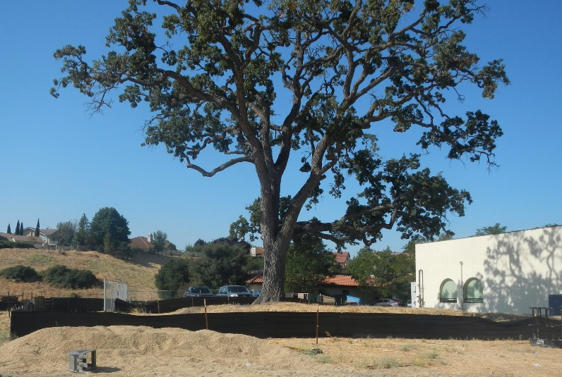
The initial site assessment should identify any sensitive or protected habitats or natural resources present on the site. Site designs that protect and avoid disturbing sensitive features such as creeks, heritage or protected trees, and wetlands should note this strategy as a means of complying with PR#1.
Avoiding disturbance of these types of sensitive features can also reduce the need to obtain additional agency permits.
Figure 10: Protection of sensitive biological resources can be integrated as compliance with PR#1.

Special Considerations
In extenuating circumstances, applicants may apply for a finding of technical infeasibility to comply with PR#3. A finding of technical infeasibility does not waive any portion of the compliance requirements for PR#1 or PR#2 at the site.

Technical Infeasibility- Alternative Compliance
The PCRs allow two (2) options for alternative compliance with PR#3 retention requirements: the 10% Equivalent Impervious Area Adjustment (10% EISA adjustment), and off-site compliance.
Both options require a demonstration that full on-site compliance is technically infeasible. A finding of Technical Infeasibility will not apply to PR#1 or PR#2 requirements, which must still be achieved on-site. To propose a finding of technical infeasibility, the SWCP must include a complete and thorough implementation of opportunities for implementing LID on-site. The SWCP must also include a detailed opportunities and constraints analysis and site map, as detailed in Appendix B.
The conditions which merit a finding of technical infeasibility are detailed in the PCRs and summarized in Table 10. Applicants must submit a site-specific hydrologic and/or drainage design analysis conducted and endorsed by a registered professional engineer, geologist, architect, and/or landscape architect, demonstrating that compliance with Performance Requirement #3 is technically infeasible.
Sites with one or more documented constraints listed in Table 10 may be approved by the County to utilize the 10% EISA adjustment or an offsite compliance location. It is strongly recommended that applicants contact County staff to discuss technical infeasibility prior to submitting permit application documents.
Table 10: Site conditions supporting a technical infeasibility finding.
Constraining Site Conditions
The following site characteristics contribute to technical infeasibility.
Depth to seasonal high groundwater limits infiltration and/or prevents construction of SCMs;
Sites where soil types significantly limit infiltration;
Sites where pollutant mobilization in the soil or groundwater is a documented concern;
Depth to an impervious layer such as bedrock limits infiltration;
Sites where pollutant mobilization in the soil or groundwater is a documented concern;
Space constraints (e.g., infill projects, some redevelopment projects, high density development);
Geotechnical hazards;
Stormwater Control Measures could only be located within 100 feet of a groundwater well used for drinking water;
Incompatibility with surrounding drainage system (e.g., project drains to an existing stormwater collection system whose elevation or location precludes connection to a properly functioning treatment or flow control facility).

10% Equivalent Impervious Surface Area Adjustment (EISA)
Full compliance with PR#3 criteria can be waived if stormwater control features occupy an area of the site equivalent to no less than 10% of the project’s ‘Equivalent Impervious Surface Area’ or EISA.
To demonstrate compliance with the 10% EISA adjustment applicants must clearly demonstrate the following data in the SWCP:
- Divide the site into Drainage Management Areas (DMAs).
- Tabulate the total fully impervious square footage in each DMA.
- Tabulate the pervious square footage in each DMA.
- Multiply the square footage of pervious surfaces in each DMA by the correction factors shown in Table 11.
- Total the contributions of the pervious and semi-pervious surfaces in all DMAs. This is the EISA for the site.
To calculate the required SCM area for the 10% adjustment factor:
- Calculate the square footage of bioretention or other retention based SCM facilities required for the site using the simple method or calculator.
- Divide the required SCM area by the EISA to determine the 10% adjustment area.
Table 11: Correction factors for calculating Equivalent Impervious Surface Area.
Pervious Surface | Correction Factor
Disturbed soils / managed turf  (dependent on original Hydrologic Soil Group) | A: 0.15  B: 0.20  C: 0.22  D: 0.25
Pervious Concrete | 0.60
Cobbles | 0.60
Pervious Asphalt | 0.55
Natural Stone (without grout) | 0.25
Turf Block | 0.15
Brick (without grout) | 0.13
Unit Pavers on Sand | 0.10
Crushed aggregate | 0.10
Grass | 0.10

Off-site Mitigation
Nearly all proposed development should be able to attain onsite compliance through the use of LID or the 10% EISA adjustment. Applicants seeking to construct offsite mitigation must submit a description of the project(s) that will provide off-site mitigation. The proposed off-site project(s) may be existing facilities and/or prospective project(s) that are as effective in maintaining watershed processes as implementation of the applicable Post-Construction Stormwater Requirements on-site. The description in the SWCP shall include:
- The location of the proposed off-site project(s) must be within the same watershed as the Regulated Project. Alternative Compliance project sites located outside the watershed may be approved by the Central Coast Water Board Executive Officer
- A schedule for completion of offsite mitigation project(s), where the off-site mitigation project(s) has not been constructed.
- A preliminary design for the off-site mitigation project.

The County will require applicants proposing Off-site Mitigation to construct the off-site project concurrent with the development project requiring PCR compliance. Permits for the triggering project will not be granted Final status until the off-site project is fully constructed.

On-site offset
LID measures and SCMs must be sized to address all post-construction flows and/or volume they receive onsite. If this is not possible, applicants may propose oversizing another SCM on the project site within a different tributary area or DMA to offset the shortfall. This practice is referred to as an “on-site offset.”
The feature identified for upsizing should receive runoff from a similar surface type or site use as the area that cannot be treated. Justification for the use of an on-site offset must be provided to the County, and approval is at the discretion of County staff. The County generally will not consider the use of an on-site offset for more than 10% of the total post-construction runoff volume
The SWCP should include an explanation and figure demonstrating why the proposed design would not be able to accommodate all required flows and/or volume within each DMA. Most commonly, this would be due to the inability to physically route the water to the SCM location or significant space constraints due to setbacks. All reasonable means to address post-construction flows should be evaluated before requesting the use of an on-site offset.

Landscaping Requirements
Applicants should prioritize the use of County ordinance required landscaping as an opportunity to incorporate LID into the site design. Landscaping features required for screening or shading can be utilized for collecting and retaining stormwater onsite.

Maximizing landscape use and efficiency
The PCRs require prioritization of landscape-based LID features for all regulated projects and utilizing required site landscaping can be highly advantageous in reducing the scale of structural control measures. Additionally, vegetation is an important element of LID stormwater features. Plants provide a physical structure that increases infiltration into the soil and promotes a soil community of microorganisms that remove pollutants. Maintaining healthy vegetation is key to the functional benefit of stormwater treatment features.
County codes (Title 22 and Title 23) encourage the planting of native species, trees, and drought tolerant species. Generally, the County requires landscaping in the following site locations:
- Setbacks | - Unused areas of a site
- Parking areas | - Special use sites

Landscape areas typically include a combination of plant types and natural decorative materials to achieve the intended or required purpose of the landscape (e.g., screening, etc.)

Irrigation considerations
Consistent with the Model Water Efficient Landscaping Ordinance (MWELO) an irrigation plan consistent with County codes is required during the application process and is submitted as part of the landscape plan. Title 22 and Title 23 specify the requirements for irrigation methods, equipment, and scheduling.
During drought emergencies, vegetation installed as part of a SCM will be considered functional landscaping and waived from watering prohibitions associated with non-functional turf or landscaping. All functional vegetation installed as part of SCMs should be significantly mature at 24 months following planting to minimize the need for continued irrigation. Where available, the use of municipally provided Recycled Water for landscape irrigation (including vegetated SCM plant establishment) is authorized and encouraged.

Parking Lot Landscaping Requirements
County codes require that all parking lots of three (3) or more spaces contain sufficient trees so that within 10 years, 60% of the surface area of the lot is shaded. This requirement is in addition to any required perimeter landscaping required for screening.
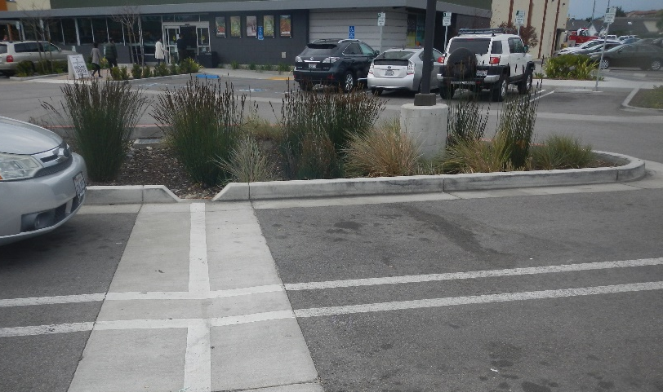
Applicants are encouraged to utilize landscaped areas within parking lots as self-retaining areas or treatment SCMs to infiltrate stormwater generated by the adjacent impervious surfaces of the parking lot. Optimizing this method of indirect infiltration reduces the irrigation demand of the site and supports compliance with multiple performance requirements.
Figure 11: Recessed vegetated median with valley drain and curb cut to accept stormwater.

Utility Conflicts
Utility lines and connections are common and necessary components of infrastructure within the right-of-way, and typically extend into private property. Designers should evaluate utility locations and determine where setbacks and sleeving requirements may impact opportunities for perimeter LID features or SCMs. In some scenarios utility providers may authorize placement in LID features with the use of insulating wrap, impervious water stops, or utility trench dams.
Applicants should coordinate with local utility providers to determine setback or encasement requirements for existing or future utilities. Applicants should also consult with any applicable building or plumbing codes that may provide any minimum setback requirements between existing or future utilities and SCMs.
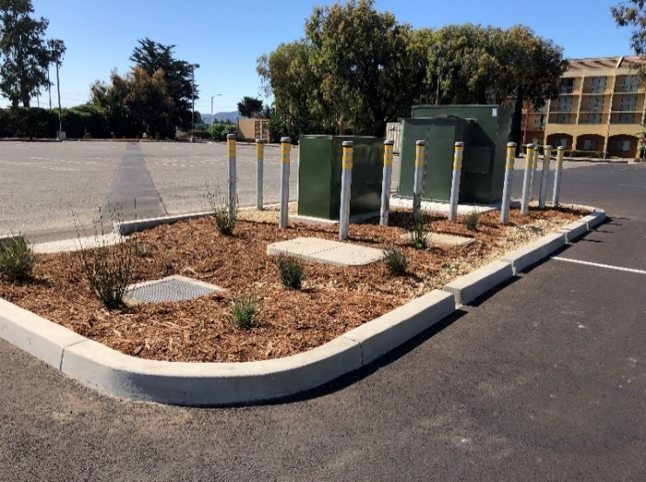
Placing above-grade utility infrastructure within LID features and SCMs should be avoided to prevent disruption of infiltration, flow routing, and maintenance access.
Figure 12: Utility infrastructure in a bioretention feature and obstructing a stormwater swale.

Site Definition and Run-On Control
Stormwater run-on is the drainage generated from upstream tributary areas (developed or undeveloped) that flows into the project site. County ordinance does not authorize modifying or significantly altering the path of existing drainage for the purpose of protecting new development. The historical drainage path is to be maintained exiting the site to avoid damaging downstream properties and/or facilities, and this will need to be accounted for in the planning and construction phases. Drainage entering the site needs to be carefully evaluated and incorporated into project design. Structural SCMs must be adequately sized to accommodate the runoff that they receive, whether it be site generated runoff, or upstream run-on.
Redevelopment projects should carefully evaluate existing runoff and run-on conditions. Projects that expand the footprint of development on an existing site may be required to address and accommodate the runoff generated by existing site infrastructure if it cannot be isolated from the new development, which is also applicable to road widening improvements.

Minimizing the Size of SCMs
Runoff reduction measures can be integrated into the site design to reduce the amount treatment and retention required. Design measures such as directing roof downspouts to landscaping or routing parking lot drainage into landscaped areas, can dramatically reduce the amount of stormwater that needs to be managed by SCMs. These types of site design features meet all the criteria of LID; they are small scale, vegetated, and infiltration based.
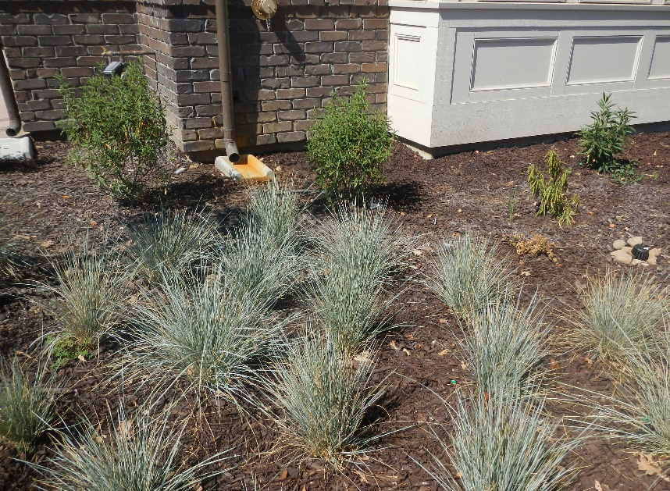
Runoff reduction measures are generally not dependent on site constraints and should be considered for use with all projects. These measures also include rainwater harvesting, green roofs, buffer strips, and flow through planters.
Figure 13 Downspout directed to site landscaping.

Structural Stormwater Control Measures
Once the site has been assessed and opportunities and constraints identified, designers can begin delineating drainage management areas (DMAs) and determining which structural SCMs may be appropriate for the site. The SCMs described in this chapter will contribute to managing and reducing stormwater runoff volume, rate, and/or pollutants from the site, and should be used to augment LID measures to meet the performance requirements.

Drainage Management Area Delineation
Projects that meet the criteria for PR#2 or greater must delineate the site into Drainage Management Areas (DMAs) to document the decentralized stormwater management design approach. DMAs are portions of the developed project site that will drain to a common location. The entirety of the site must be tabulated into DMAs, with each DMA ideally containing only one type of surface (i.e. vegetation, impervious, or semi-pervious surface.) Each DMA must be clearly identified and labeled in an exhibit, with corresponding characteristics summarized in tabular format. DMAs should not overlap.

Types of DMAs
DMAs are typically delineated by grade breaks and surface cover types and drain to a common location of the site. There are four (4) accepted categories of DMAs:
- Self-retaining areas | - Self-treating areas
- Areas draining to self-retaining areas | - Areas draining to LID features or SCMs
Self-retaining areas provide passive stormwater treatment and retention and can be highly advantageous in meeting multiple performance requirements. Self-retaining areas include depressed vegetated areas with either landscaping or native vegetation or pervious pavements.
It is acceptable to direct runoff from another DMA with impervious cover to a self-retaining area. However, the maximum allowable ratio for this design strategy is 2 parts impervious area to 1 part pervious area. Runoff from the impervious area draining to the self-retaining area must be dispersed across the pervious self-retaining area. To utilize this strategy, the self-retaining area must be sized to hold a volume equal to both areas times a depth of 1-inch. This chapter includes additional guidance on run-on ratios for pervious pavements in section 5.i.
Self-treating areas are landscaped or undisturbed areas of the site that do not generate or receive stormwater runoff from other areas. Generally, self-treating areas are flat, depressed, or gently sloped, ensuring that stormwater will infiltrate into the soil. To qualify as a self-treating DMA each of the following characteristics must be present:
- The area is vegetated with native and/or non-invasive drought tolerant species that do not require permanent irrigation or regular application of fertilizers.
- If located in an area where soils have been disturbed, soils have been amended and aerated to promote infiltration characteristics equivalent to undisturbed native topsoil.
- Any incidental impervious areas are less than 5 percent of the self-treating area.
- The self-treating area is hydraulically separate from DMAs that contain permanent SCMs.
DMAs draining to constructed SCMs are typically characterized by a significant proportion of impervious surface. The impervious area within these DMAs is used to determine the necessary volume and footprint of the SCM. For each DMA draining to a SCM, determine the square footage, type of surface, and corresponding runoff factor. This information is used for sizing runoff retention and/or water quality treatment SCMs. Additional information on these calculations and resources to complete them are provided in Chapter 6. It is allowable for more than one (1) DMA to drain to an SCM. However, drainage from a single DMA should not be split among multiple SCMs.

DMA Sizing Guidelines
The objective of the decentralized approach of the PCRs is to manage the stormwater from each DMA with LID design features or a SCM. While a variety of factors will influence the size of each DMA, the guidelines in Table 12 should be incorporated into the delineation process.
Table 12: Drainage management area sizing guidelines.
Decentralized Drainage Management Area Guidelines
The following guidelines are recommended for ensuring an appropriately decentralized stormwater management approach.
Single-family Residential Project DMAs (including parcels and access roads/driveways):
- Minimum of three (3) DMAs for sites less than one (1) acre in total area.
- Each DMA less than five (5) acres in total area.
- Each DMA less than one (1) acre total impervious area.
- Each DMA less than ten (10) individual residential lots.
- Each DMA should avoid comingling of runoff from multiple land uses where feasible.
- DMAs with access roads should include ¼ mile or less of roadway.
- DMAs should be no less than 250 square feet or 2% of the project site.
Commercial, Industrial, Multi-family residential projects (including public improvements):
- DMAs should be land-use specific (i.e. parking, rooftop, access roads, equipment/processing areas.)
- Each DMA less than three (3) acres total area.
- Each DMA less than one (1) acre total impervious area.
- DMAs should be no less than 250 square feet or 2% of the project site.
- Each DMA should avoid comingling of runoff from multiple land uses where feasible.
Roadway projects (public improvements only):
- DMA for local roadways ¼ mile or less.
- DMA for collector roadways 1/8 mile or less
- DMA for arterial roadways 1/8 mile or less.

Delineating DMAs across Public and Private Property
Projects that include both public and private improvements may find it necessary to delineate DMAs that span both areas. For instance, a project may be required to construct curb, gutter, and sidewalk improvements within the public Right-of-Way or existing roadway stormwater may flow onto the project site at the area of conform of the new frontage improvements and existing roadway. If the areas cannot be isolated with an asphalt berm or other method, then this would be a shared DMA between the roadway and the project site. Alternatively, distinct DMAs for public and private improvements may be delineated, with one DMA draining into another to reflect site drainage patterns.
The same would be true of a project located in a rural area not subject to curb, gutter, and sidewalk requirements.

Structural Control Measure Types
The County recognizes a defined suite of stormwater structural control measures that support compliance with the PCRs. These structural SCMS are categorized, defined, and named by common characteristics. The intent of categorizing specific types of SCMs is to promote consistent nomenclature across the County and project documentation.

Recognized SCM Types and Descriptions
The County recognizes and accepts only these standardized types of structural SCMs summarized and described in Table 13.
Table 13: Stormwater structural control measures.
SCM Type | Description | Key Characteristics | Applicable Performance Requirement(s)
Biofiltration/  Bioretention | Vegetated feature that filters stormwater through a specialized soil media and includes aggregate subsurface layer to enhance storage or infiltration. Biofiltration includes an underdrain for discharges where infiltration rates are poor. Allows for inundation of vegetated areas during storm runoff. | - At-grade, no slope.  - Vegetated (50%+)  - Indirect infiltration via aggregate subsurface layer and native soil bed. | PR1  PR2  PR3
Vegetated Swale | Vegetated feature with up to 4% slope that conveys stormwater and provides water quality filtration by vegetation. Design includes gently sloped flow paths and dense vegetation to promote stormwater surface filtration and velocity reduction by vegetation (settling). | - Vegetated to minimum 50%  - Not designed for infiltration. | PR1  PR2
Vegetated Buffer Strip | Gently sloped vegetated feature adjacent to an impervious area that receives stormwater runoff flows as sheet flow. Provides water quality filtration by vegetation. | - Vegetated to minimum 70%  - Retention volume credit may apply with PR3 design guidelines | PR1  PR2  PR3
Filtration Device | A flow-through structure or product designed to capture and retain sediment, leaf litter, trash, and coarse particles. Typically accepts runoff from road or a single land use paved area. | - Below-grade.  - Non-vegetated.  - No infiltration or retention volume credit. | PR2
Infiltration Feature (includes underground infiltration chambers) | Structure designed to retain and infiltrate stormwater. Existing soils and grades may be modified to sustain maximum infiltration rates. | - At or below-grade.  - Non-vegetated.  - Retention volume credit applies via direct infiltration. | PR3  PR4
Pervious Pavement | Durable materials that create a pervious surface that allows stormwater to infiltrate into the underlying soil. May include an underlying reservoir to increase retention capacity and infiltration rates. Constructed to minimize the volume of stormwater generated. | - At-grade  - Non-vegetated.  - Retention volume credit may apply if structural section includes retention capacity. | PR1  PR2  PR3
Infiltration (Retention)  Basin | A feature designed to store and infiltrate significant volumes of stormwater into unsaturated zone. Infiltration rates may be augmented with a highly permeable substrate. Vegetation distribution is limited to grass or unvegetated. May be below the lowest outlet of a detention basin. | - At grade.  - Minimally vegetated or non-vegetated.  - Infiltration/retention volume credit applies. | PR2  PR3  PR4
Detention Basin | A flow through basin with discrete inlets and outlets to detain stormwater runoff for some minimum time to reduce peak flows. One or more outlets may exist at different elevations. | - At-grade. | PR4
Media Filter | A proprietary subsurface flow-through structure that uses a membrane or media to actively filter stormwater pollutants. Pollutant load reductions achieved but no stormwater volume reduction occurs. | - Primarily below-grade.  - Non-vegetated.  - No infiltration/retention volume credit. | PR2
Treatment Vault | A subsurface flow-through structure that physically separates sediment, trash, leaf litter, debris or other particulates by separation or settling. Pollutant load reductions achieved but no stormwater volume reduction occurs. | - Below-grade.  - Non-vegetated.  - No infiltration/retention volume credit | PR2

SCMs Types for siting in the County Right-of-Way
A limited suite of the structural SCMs listed in Table 13 is approved for construction in the County’s Right-of-Way. The County’s Public Improvement Standards allow for the use of a roadside infiltrator design that can be installed beneath sidewalks. Additionally, biofiltration, bioretention, vegetated buffer strip or vegetated swale SCMs may be placed in the shoulder along the roadway. In cases where Right-of-Way generated stormwater is routed to private onsite SCMs, additional types of SCMs are permitted. Runoff from private property development (onsite) may not be directed to any SCM in the public Right-of-Way.

Prioritization of Low Impact Development
Small scale, landscaped-based LID infiltration features that treat stormwater as close to the source as possible are the highest-priority for the site design. LID design features should be considered and incorporated for use with all projects. Identifying these features in both the SWCP and on project plans is critical for demonstrating compliance with PR#1. Engineered and proprietary structures such as underground infiltration chambers, hydrodynamic separators, and lined detention basins are not LID strategies. Compliance with the prioritization framework illustrated in Figure 14 must be documented in the SWCP and proposed design especially where any mechanical, proprietary, or subsurface SCMs are proposed.
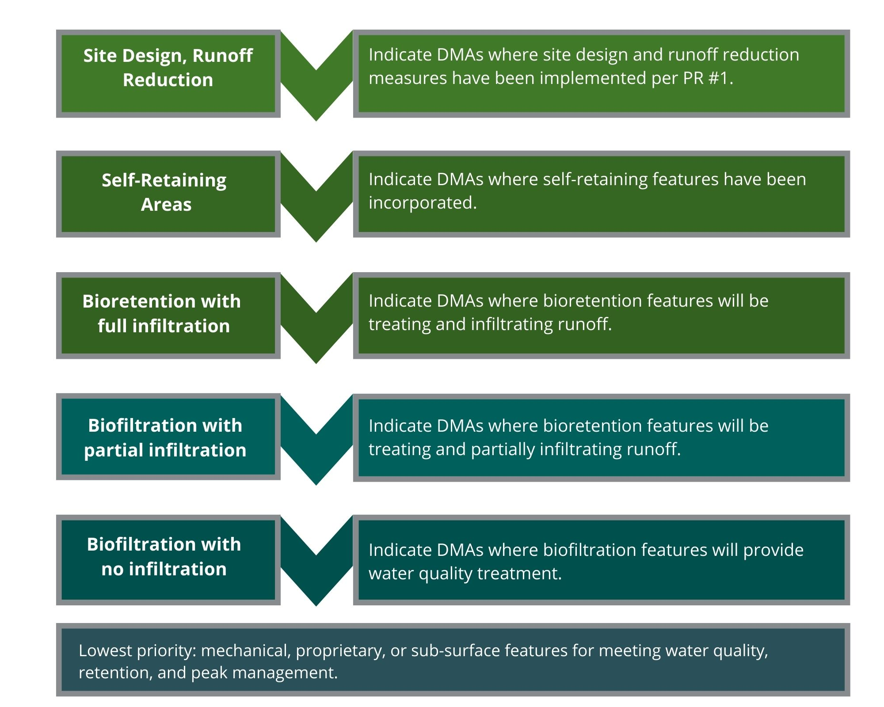
Figure 14: Low impact development prioritization framework.
Applicants must demonstrate that significant effort has been made to incorporate LID strategies into the design before proposing mechanical or subsurface features. Very few projects are constrained to the extent that they preclude management of a majority of post-construction runoff via LID measures.
Underground infiltration chambers, hydrodynamic separators, vault systems, or treatment devices are not considered LID design elements and should be limited to the DMAs where all other LID design options are infeasible. If exceptional site constraints render management of post-construction runoff via LID measures infeasible, then designers should demonstrate that a minimum of 30% of the site’s post-construction runoff volume has been managed through LID strategies or at-grade vegetated features before proposing compliance measures utilizing ‘grey’ or subsurface infrastructure.

Documenting compliance with PR#1
All regulated projects must demonstrate compliance with PR#1. Compliance with PR#1 must be clearly documented in the SWCP App and/or SWCP and reference a specific plan sheet and detail in the construction plans that demonstrates the location of the strategy selected. PR#1 strategies benefit the overall project design by reducing the volume of runoff that must be treated, retained, and managed in accordance with PR#2, PR#3 and PR#4. Achieving compliance with the quantitative targets of PR#3 and PR#4 does not supersede the need to demonstrate that PR#1 has been met. However, PR#1 requirements could be met by directing runoff from an impervious DMA to a vegetated area or SCM designed to meet PR#2 and PR#3 requirements.

Self-treating areas, self-retaining areas
Self-treating and self-retaining areas are considered LID features, as they are typically vegetated and additionally reduce the overall imperviousness of the site. Incorporation of self-treating and self-retaining DMAs into the project design is an effective means of demonstrating compliance with PR#1. The locations and dimensions of self-treating and self-retaining areas should be clearly noted on plans and documented in the SWCP.

Rainwater harvesting and reuse systems
Rainwater harvesting systems are designed to collect and store runoff for later use and are considered a LID practice. These systems store a specific volume of water and must be designed with a safe bypass or overflow route for rain events that exceed the design capacity. Collection systems or cisterns with a storage capacity of at least 100 gallons meet the requirements of PR#1.
Water quality treatment and water reuse limitations vary significantly based upon the surface from which the runoff is harvested. Per the California Building Code, runoff from above grade surfaces (rooftops, shade structures) is classified as non-potable water and requires only modest screening and filtration for irrigation reuse. Runoff from at-grade surfaces and flatwork (driveways, walkways, parking areas, etc.) is classified as graywater which requires significantly greater treatment and has more restricted reuse applications.
Applicants proposing capture and reuse systems are advised to closely review California Plumbing Code Chapters 15 and 16 which detail requirements for siting, water quality treatment, connections, inspection, and testing of these systems.
Consistent with the California Building Code, the County does not require separate permitting for rainwater harvesting systems collecting less than 360 gallons for outdoor irrigation reuse. Additionally, rainwater harvesting systems collecting up to 5,000 gallons may be constructed without individual permitting provided that tanks are constructed at-grade, with no electrical connections, and meet a 2:1 height to width ratio.
Larger capacity harvesting systems, subsurface systems, systems that collect graywater (as defined by the California Plumbing Code), and systems proposed as the method of complying with PR#2 or above, are subject to separate County permitting. Plans must indicate backflow prevention controls, a safe overland bypass/escape, and detailed irrigation schedule that includes the site’s irrigation demand and the maximum drawdown period for stored rainwater in all weather conditions.
Designers should reference the drawdown periods, credits, and sizing requirements in Table 14 when designing a rainwater harvesting system requiring County permitting. In all cases, a debris excluder and 100-micron filter are required on rainwater or greywater collection systems.
Table 14: Rainwater harvesting crediting and drawdown.
Planned Drawdown / Reuse Period | Sizing Requirements to meet PCRs | Volume credit applied to County flood control standards
Under 48 Hours  (Less than 2 days) | Design storm.  Meets PR#1, PR#2, PR#3. | 100% stored volume.
Up to 72 hours  (Up to 3 days) | Design storm x 1.2  Meets PR#1, PR#2, PR#3. | 100% stored volume.
Up to 7 days | Design storm x 1.2  Meets PR#1, PR#2, PR#3. | 100% stored volume.
Up to 14 days | Design storm x 1.2  Meets PR#1, PR#2, PR#3. | 0% stored volume.
Greater than 14 days | Design storm x 1.2  Meets PR#1, PR#2, PR#3. | 0% stored volume.
*The Design storm may be the 85th or 95th percentile 24-hour storm depth depending upon the WMZ.
Permitted systems reusing stored water for irrigation in commercial or multi-family settings must also post permanent signage indicating that the source of irrigation water is un-treated rainwater. Single family residential systems are exempt from this signage requirement, unless utilizing spray irrigation in a publicly accessible area.
The project’s operations and maintenance plan must include all required maintenance activities per the schedule in Chapter 16 of the California Plumbing Code, in addition to any site-specific maintenance or inspection activities.

Structural Stormwater Control Measure Selection
This section provides information for common SCMs including a description, advantages, limitations, key design features, and sizing design tips. Each DMA should be evaluated to determine the most appropriate SCM with careful consideration of information from the initial site assessment.

SCM Purpose: Flood Control Requirements and the PCRs
SCMs designed for compliance with the PCRs may not be suitable for addressing the retention or detention volume requirements set by the County’s drainage and flood control standards. In some locations these flood control standards require retaining or detaining a significantly greater volume of stormwater.
Modifying bioretention or biofiltration SCMs to accommodate a deeper surface ponding area to increase basin volume can be detrimental to the functionality of these features. While bioretention plantings are typically able to withstand 72 hours of inundation, repeated or prolonged inundation of a bioretention facility can damage plants and create vector control issues. The ponding depth for biofiltration and bioretention features should not exceed 12-inches.
If a site’s SCMs do not contain adequate volumes to meet additional drainage or flood control standards, it is recommended that SCMs be designed with overflows and conveyance to additional downstream facilities. The downstream facilities (typically a basin) can be sized for the supplemental volume needed to achieve compliance with other standards. With this approach, decentralized, LID-compliant SCMs can be utilized to the maximum extent feasible while providing greater flexibility for the design engineer in managing volumes beyond the PCR requirements.
For example, consider a project that must meet PR#1-3 and County flood control requirements on a space-constrained site. The design engineer has identified that County flood control volumes for retention or detention will exceed the volumetric retention requirement of PR#3. Bioretention facilities with adequate surface area to meet flood control requirements as well as LID ponding depth exceed available surface area. The design engineer opts not to pursue the extensive amount of subsurface exploration and excavation likely necessary to provide a subsurface retention facility that meets all standards for PR#3 and County flood control volumes. Instead, taking advantage of the reduced volumetric safety factors offered for bioretention facilities, the design engineer distributes a limited number of bioretention basins throughout the site to meet PR#2 and PR#3. These overflow to an onsite drain that outlets in a modest surface detention basin designed to County flood control standards (accounting for storage provided by the bioretention basins). This design concept is explicitly encouraged by the County.

Setbacks
SCMs that utilize direct or indirect infiltration must be sited in a manner that minimizes impacts to existing and planned infrastructure. In some cases, existing infrastructure on neighboring properties may limit the siting of large SCMs. Thorough site assessment is necessary to ensure that the setbacks noted in Table 15 can be achieved. The setbacks suggested in Table 15 are suggested minimum values, and additional setbacks may be deemed necessary by the design and/or geotechnical engineer based upon site risk factors and geotechnical hazards.
Table 15: Minimum lateral setbacks for SCMs.
SCM Type | Setback | Minimum Distance
Infiltration feature, pervious pavement, infiltration basin.  (Including dry wells, underground infiltration chambers and roadside infiltrators.) | Property line | 10 feet
 | Water well | 100 feet
 | Structural foundation  (buildings or walls) | 10 feet^{(a)}
 | Basements | 100 feet upslope,  20 feet downslope
 | Onsite wastewater treatment systems (leach fields) | 150 feet
 | Underground storage tanks | 10 feet
 | Road easements | 10 feet from edge of easement width^{(c)}
 | Descending slopes or bluffs | 100 feet^{(a)}
 | Reservoirs, ponds, lakes | 100 feet
 | Seasonally high groundwater^{(b)} | 10 feet (vertical separation)
 | Streams, creeks, or springs | 100 feet
Biofiltration, vegetated swale, vegetated buffer strip, bioretention. | Property line | 5 feet
 | Water well | 100 feet
 | Structural foundation | 5 feet^{(a)}
 | Basements | 100 feet upslope,  20 feet downslope^{(a)}
 | Onsite wastewater treatment systems (leach fields) | 100 feet
 | Underground storage tanks | 10 feet
 | Road easements | 10 feet from edge of easement width^{(c)}
 | Descending slopes or bluffs (10% or steeper) | 100 feet ^{(a)}
 | Reservoirs, ponds, lakes | 50 feet
 | Seasonally high groundwater | 5 feet (vertical separation)
 | Streams, creeks, or springs | 50 feet
 | Streams, creeks, or springs | 50 feet
(a) Setback may be modified with site specific certification from geotechnical or structural engineer.
(b) Seasonally high groundwater is the highest elevation of the water table during the wettest season of the year. The depth should be determined using available data including soil borings and historical records.
(c) Setback applies only to features managing runoff from private improvements.

SCMs for constrained sites
A variety of site constraints may impact the overall drainage layout and design. It is important to note that even at sites that meet the criteria for technical infeasibility, a minimum10% of the EISA will need to be dedicated to stormwater treatment and retention. Strategies for achieving PCR compliance on constrained sites or demonstrating compliance with the 10% EISA criteria may include:
- Utilizing all areas of required landscaping as self-retaining DMAs.
- Incorporating pervious pavement systems for uncovered parking areas, driveways, or alleys.
- Installing rainwater harvesting systems for onsite irrigation reuse.
- Installing rooftop gardens or vertical gardens that serve as self-treating DMAs.
Sites that are constrained by geologic limitations or soil contamination should contact County staff early in the design process and consider securing an offsite location for alternative compliance. The criteria for demonstrating technical infeasibility are further detailed in Chapter 4.

Bioretention and Biofiltration
Vegetated bioretention and biofiltration features are the highest priority features for managing post-construction runoff. Bioretention and biofiltration treatment systems remove pollutants using natural systems utilizing enhanced soil media and vegetation and provide water quality benefits via several important mechanisms:
- Biologically active soil media provides media filtration.
- Vegetation provides filtration via straining, interception, settling of particles resulting from shallow flows,
- Sorption processes capture pollutants via absorption, ion-exchange, surface complexation, etc.
- Soil microbes support biologically-mediated transformations.
Bioretention and biofiltration features can typically be fit into parking medians, perimeter screening landscape areas, and other landscaping features without significantly affecting the uses or layout of the site. Further, bioretention facilities contribute towards site landscaping requirements, attenuate peak flows, and effectively remove common pollutants of concern. Bioretention and biofiltration features may be of any shape, but should incorporate the following characteristics as demonstrated by Figure 15:
- Surface reservoir equal to the biofiltration treatment system surface area times a depth of 6 inches.
- Specialized bioretention soil media depth of at least 24 inches.
- Subsurface drainage/storage (gravel) layer with an area equal to the biofiltration treatment system surface area and having a minimum depth of 12 inches.
- All layers constructed as flat, level surfaces, with no longitudinal slope.
- No compaction of soils beneath the biofiltration facility.
- Proper plant selection for both inundation zones that sustains 50% vegetated cover once established (typically within 12-24 months).
- Non-floatable wood mulch or pea gravel surface cover as appropriate.
- Stabilized inlets where concentrated inflows enter the feature.
- Overflow outlets or underdrains as necessary.
- No liners or other barriers interfering with infiltration, except for situations where lateral infiltration is not technically feasible.
Figure 15: Bioretention/biofiltration feature common construction characteristics.
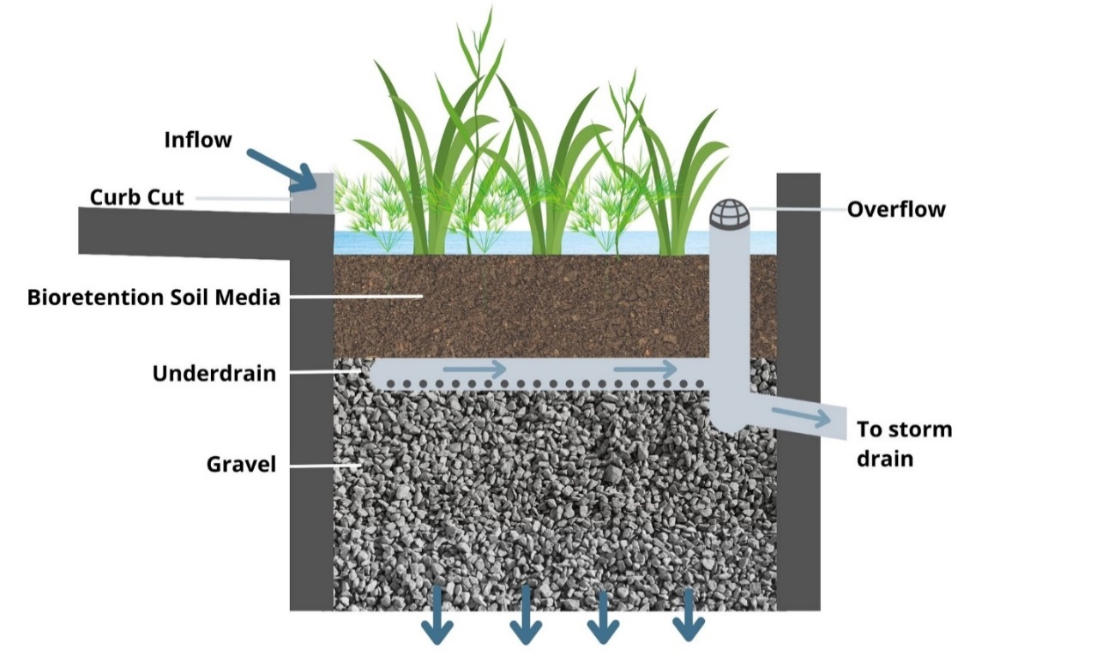
The planting media installed in biofiltration and bioretention features must be highly permeable (sustaining a minimum infiltration rate of 5 inches per hour) with a high concentration of organic matter to function effectively. This mixture is typically comprised of 60-70% sand and 30-40% compost. All planting media components should be free of stones, stumps, roots or other detritus greater than ¾” in size. Once installed, the planting media should be covered with nonfloatable mulch which will help suppress weeds and maintain infiltrative capacity. Aged mulch, also called compost mulch, has less tendency to float than bark mulch and should be prioritized where available.
There are two planting zones associated with bioretention and biofiltration features, based upon the potential frequency of inundation. The planting zones are indicated in Figure 16 and referenced in the plant palette recommendations in Appendix D. Plant species should be selected and planted based upon the planting zone. A minimum 50% vegetated plant cover of the bioretention or biofiltration feature should be achieved at plant maturity. Plant maturity is anticipated to occur between 12-24 months following planting. Applicants are encouraged to review the simplified plant palette recommendations in Appendix D of this guidebook.
Figure 16: Bioretention/Biofiltration planting zones.
Installation of structures into bioretention and biofiltration features that interfere with light penetration to LID vegetation, inhibit inspection and maintenance, or disturb subgrade aggregate material or bioretention soil are not permitted. This includes but is not limited to: raised decks, docks, or walkways, solar panels, monument signs, etc.

Vegetated Swales and Buffer Strips

Vegetated Swales
Vegetated swales differ from biofiltration and bioretention features in that they are used to convey flows down a gentle slope. Vegetated swales are intended to meet the requirements of PR#2 only.
Siting of vegetated swales must consider soil types, inflow volumes and the ability of the swale to support 50% cover of selected vegetation. Once graded, bottom soils in the swale should be de-compacted to a depth of twelve (12) inches and amended with four (4) inches of compost to support plant establishment and water quality treatment.
Check dams should be provided for slopes that exceed 2.5%. Check dams must be adequately embedded into side slopes and should be constructed of concrete, wood, metal, or sheet pile. Earthen and stone check dams are not recommended due to risk of erosion. The area downslope of the check dam should be armored with gravel or cobble to minimize erosion. High flows should safely flow over the check dam without an increase in upstream flooding or damage to the check dam. Swales may also need to meet flood control requirements per the County’s Public Improvement Standards. Equations for determining the required swale length and number of check dams are provided in Chapter 6.
The planting zones referenced in Figure 16 and the palettes provided in Appendix D may be applied to vegetated swales. Table 16 provides a summary of the County’s vegetated swale design criteria.
Table 16: Vegetated swale design criteria
Design Element | Minimum Value | Maximum Value
Bottom width | 2 foot as trapezoid | Up to 10 feet as trapezoid.
Side slopes | No minimum. | 3:1
Longitudinal slope | 0.25% | 1% -2.5% ª
Length of flow path | 10 feet. | None.
Velocity | No minimum. | 1.0 ft/sec for PR#2 flow
Vegetation coverage | 50% cover | None.
Hydraulic Residence Time | 5 minutes | None.
ª Vegetated swales that incorporate check dams may utilize an average overall slope up to 4%. The bed slope between check dams must be 2.5% or less.

Vegetated Buffer Strips
Vegetated buffer strips are designed to filter shallow sheet flow runoff, and meet the requirements of PR#2 and in some cases PR#3. Vegetated buffer strips are most commonly used for treating stormwater runoff from adjacent impervious surfaces that drain by sheet flow, such as roadways, driveways, or parking lots.
Siting of vegetated buffer strip must consider soil types, inflow volumes and the ability of the strip to support selected vegetation, typically drought tolerant native grasses. Once graded, surface soils in the strip should be de-compacted to a depth of twelve (12) inches and amended with four (4) inches of compost to support plant establishment and water quality treatment. Table 17 provides the County’s vegetated buffer strip design criteria for meeting PR#2 requirements.
Table 17: Vegetated buffer strip design criteria for PR#2
Design Element | Minimum Value | Maximum Value
Strip width | 10 feet if sloped 5% or less.  15 feet if sloped exceeding 5% | None.
Strip slope | 1% | 40% (2.5 :1)
Tributary Length  (length of contributing flow path) | None | 100 feet
Vegetation coverage | 70% cover | None.
Compost incorporation: apply four (4) inches of compost over strip area and incorporate to depth of twelve to sixteen (12-16) inches.

Figure 17 demonstrates the minimum vegetated buffer strip widths based upon strip slope. Note that the strip width is not determined by the slope of the tributary area, but by the slope of the strip itself.

Figure 17: Vegetated buffer strip design schematic.
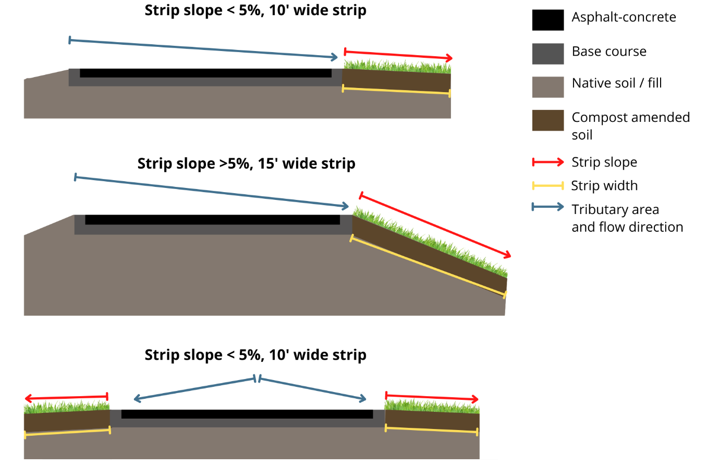

Vegetated buffer strips may also be designed to provide infiltration to meet the requirements of PR#3. Table 18 provides the County’s additional vegetated buffer strip design criteria for meeting PR#3 requirements.

Table 18: Vegetated buffer strip design criteria for PR#3
Design Element | Minimum Value | Maximum Value
Strip width | 10 feet if sloped 5% or less.  15 feet if sloped exceeding 5% | None.
Strip slope | 1% | 10%
Vegetation coverage | 70% cover | None.
Additional PR#3 Requirements for design rainfall 2” or less
Soil Type | Compost Depth / Incorporation Depthª | Maximum Tributary Area^{b}
HSG A or B | 4” / 12” | 2:1
HSG C or D | 6” / 18” | 1.5:1
Additional PR#3 Requirements for design rainfall greater than 2”
Soil Type | Compost Depth / Incorporation Depthª | Maximum Tributary Area^{b}
HSG A or B | 6” / 18” | 2:1
HSG C or D | 6” / 18” | 1:1
- Compost Incorporation: Apply specified depth of compost over strip area and incorporate to a depth equal to or greater than the incorporation depth shown.
- Maximum Tributary Area is specified as tributary area : strip area.

Proprietary units and specialized materials
A wide array of proprietary devices and materials are available for augmenting post-construction stormwater management. Proprietary devices are commercial products that typically provide stormwater treatment in space-limited applications, often using patented innovative technologies. Proprietary stormwater management devices include specialized biotreatment soil mixtures, hydrodynamic separation, catch basin insert technologies, or cartridge filters.
The County does not maintain a list of "approved" proprietary units or materials. Generally, any proprietary device or materials proposed for compliance with the PCRs must meet the following minimum standards:
- Devices and materials must not adversely affect the level of flood protection provided by the drainage system.
- Proprietary units must treat for the following pollutants of concern: sediment, petroleum hydrocarbons, nutrients, metals, and bacteria.
- Proprietary units or materials may not contain antimicrobial products or coatings.
- Devices must be vector-resistant, with a ponding duration less than 72 hours after the end of a storm.
- Devices may not adversely impact water quality by resuspending trash, sediments, or bacteria (through regrowth), or by leaching heavy metals or semi-volatile organic compounds during subsequent storms.
- Subgrade equipment or devices with access shafts must:
  - Meet or exceed American Public Works Association (APWA) standards,
  - Be reasonably accessible by a qualified maintenance worker with appropriate provisions for confined space entry.
  - Have ladder rungs, and safety guard rails.
  - Can withstand lateral soil pressures.
- Devices with plastic or fiberglass interior parts with the potential to break or shatter in the path of direct flow are not permitted.
- Pipes, conduits and vaults shall not be more than 20 feet below finished grade, and must be continuously accessible by a vacuum truck hose for clean-out.
- Must be designed with the ability to block off inflow and tail water backflow to isolate the device for safe maintenance and repair of the unit.
Performance shall be demonstrated with certification by an established stormwater technology assessment program. The dated approval letter and product specifications of all submitted materials, except for proprietary information, must be provided with the SWCP. The County reserves the right to disallow use of a proprietary device or material if the submitted information is incomplete, or if the system cannot reasonably demonstrate continuous, sufficient water quality treatment.

Filter units
Filter unit SCMs filter stormwater and convey it either offsite or into an infiltration system. These SCMs do not meet the objectives of LID because they do not incorporate at-grade features that provide infiltration or evapotranspiration. Filter units may be part of a treatment train in sequence with other SCMs to meet multiple performance requirements. Filter units should only be used in cases where biofiltration or bioretention is severely constrained by site conditions. Examples of pertinent site constraints that would preclude infiltration include soil contamination, shallow groundwater, and slope instability.

Proprietary device sizing
Most proprietary devices and materials are designed as flow-based treatment structures and mut be sized to capture and treat the water quality design flow rate if proposed as a stand-alone SCM. Proprietary biotreatment devices may include both volume-based and flow-based SCMs. Volume-based devices must be sized to capture and treat the water quality design volume if used as a stand-alone SCM.

Underground Infiltration Systems and Dry Wells
Dry wells and other subsurface stormwater infiltration practices that serve facilities other than single-family homes are considered Class V wells, subject to US Environmental Protection Agency (US EPA) regulations. Typically, Class V wells are shallow dry wells used to distribute a variety of fluids directly below the ground surface. By definition, a well is “any bored, drilled, driven shaft, or dug hole that is deeper than its widest surface dimension, or an improved sinkhole, or a subsurface fluid distribution system” and an “injection well” is a “well” into which “fluids” are being injected (40 CFR §144.3). Subsurface fluid distribution or infiltration systems (i.e. Stormtech, Contech, Cultech) are included in the Class V Well designation. Class V wells may be authorized to operate if they are registered with the US EPA, and only inject uncontaminated stormwater.
Applicants that submit plans to the County that include underground infiltration systems or dry wells will be notified of the need to register systems with the US EPA prior to issuance of construction permits. All Class V wells in California must be registered with US EPA’s Region 9 Office. Registration of Class V Wells is completed by filling out an online form prior to commencement of use. See Appendix C for additional information.
Designers should demonstrate that a minimum of 30% of the site’s post-construction runoff volume has been managed through at-grade LID strategies before proposing compliance measures utilizing ‘grey’ infrastructure such as underground infiltration chambers.

Soil Report Data
A soils report will be required to demonstrate soil infiltration rates in the location and at the elevation of the proposed underground infiltration system and the minimum distance to seasonally high groundwater. See Chapter 4 for additional information about required soil and infiltration testing and factors of safety.
Prior to plan approval the geotechnical engineer must provide a certification letter or report indicating that the site soils at the proposed location and elevation are suitable for an underground infiltration system and will not present a hazard to the site, adjoining properties, or public right-of-way. All minimum California Building Code Setbacks apply, in addition to any manufacturer recommended setbacks.

Pretreatment Requirements
Per the County’s Public Improvement Standards, underground infiltration system and dry well designs must incorporate a stormwater pretreatment device or feature to protect groundwater, remove solids, and ensure that particulate debris can be isolated from inflows. Pretreatment devices must be installed such that a ‘treatment train’ is created, and runoff passes through the treatment device prior to infiltration.
The County requires that pretreatment devices meet the following conditions:
- Pretreatment or basic treatment proprietary devices certified by the Technology Assessment Protocol Ecology (TAPE) Program supported by the Washington State Department of Ecology. Devices certified in the Pretreatment or General Use Level Designation (GULD) for basic treatment or pretreatment technologies are acceptable. See the link referenced in Appendix A. Alternatively, applicants may provide results of field-scale testing indicating an equivalent level of performance.
- The pretreatment requirements for PR#2 volume are met entirely upstream of the infiltration system through at-grade LID features such as bioretention or biofiltration features, and a settling vault or sump is installed at the infiltration system inlet.

Applicants may be required to provide additional studies to indicate that adequate pretreatment is achieved to protect groundwater quality. The County has no obligation to accept the use of any proposed proprietary SCM and will provide applicants a written explanation describing the rationale for any rejection of a proposed device.

Groundwater Separation
The minimum vertical groundwater separation for underground infiltration systems is 10 feet from the elevation of seasonally high groundwater. Guidance on determining the elevation of seasonally high groundwater is provided in Table 15.

Inspection Port Requirements
Underground infiltration systems must include appropriately sized inspection ports, designed to manufacturer’s specifications. Systems with multiple rows of chambers must install an inspection port in every other row of chambers. Ports must be marked ‘STORM’ and remain unobstructed.

Class V Well Restrictions
San Luis Obispo County relies heavily on local groundwater supplies to meet municipal and agricultural water demand throughout the County. While Class V wells provide a mechanism to augment infiltration to groundwater tables, protection of water quality is a paramount concern.
Class V wells will not be authorized for construction on high-risk project sites where the site use presents an elevated risk of releasing contaminants (spills), or on properties susceptible to receiving contaminants from adjacent land uses. This includes, but is not limited to:
- Vehicle repair facilities or fueling stations,
- Facilities that store, transfer or generate hazardous materials,
- Autopart recycling facilities,
- Sites with a history of spills or illegal dumping.
- Industrial facilities as defined by California’s General Permit for Stormwater Discharges Associated with Industrial Activities (Order No. 2014-0057-DWQ).
The County reserves the right to reject site designs that include underground infiltration systems in the above listed settings and others deemed high risk by the County’s Environmental Health Department. Alternatively, the County may permit underground infiltration systems where robust pre-treatment and spill containment measures will be instituted, or where there will be minimal exposure of industrial materials to stormwater.

Pervious Pavement Systems
Pervious pavement systems are constructed in a variety of formats including interlocking pavers, pervious asphalt or concrete, turf block systems, granular pavements, and geogrid systems. Pervious pavement systems are most efficient where native site soils are permeable but can be used on sites with clay soils if installed with a deep and well-drained base course. In most cases, pervious pavement systems are not recommended for installation on fill soils. Ideal conditions for most systems are flat areas with light traffic and low vehicle speeds.
To achieve compliance with Performance Requirement #1, pervious pavement systems must comprise 10% or more of the total square footage of outdoor bike lanes, driveways, uncovered parking lots, sidewalks, walkways or patios. Drainage directed to permeable pavement must be free of sediment or chemical pollutants. Runoff from vegetated or non-vegetated permeable areas is not recommended due to potential clogging of the pervious pavement.
To avoid potentially harmful seepage, pervious pavement systems should not be hydraulically connected to building foundations unless an impermeable liner is placed against the foundation. The recommended minimum setback from building foundations is 10 feet for systems without a liner.
Vehicle weight loading should be evaluated for the areas where pervious pavement systems are specified. Applicants should verify that pervious pavement systems are rated for HS-20 vehicle traffic for locations where waste-hauling trucks, freight delivery trucks, or emergency vehicles may regularly access the site.

Run-on Ratios
Pervious pavement systems meet the requirements of PR#1 and may be used as self-retaining areas if designed appropriately. The specifications of the selected system will dictate the amount of run-on that can be infiltrated through the pervious pavement area. Any contributing drainage areas must be fully stabilized to prevent soil erosion and sedimentation of the pavement system. Different run-on ratios to pervious pavement systems are demonstrated in Figure 17.
Systems with a 0:1 or 1:1 run on ratio are compliant with PR#1 and PR#2. Systems with a 2:1 run on ratio are considered self-retaining areas and must adhere to the design requirements for self-retaining DMAs.
Designs that exceed the 2:1 run-on ratio must provide additional calculations and details indicating that the system can sufficiently manage the proposed run-on volume. Installations that exceed a 2:1 run-on ratio may not provide adequate water quality treatment to meet the requirements of PR#2. Additional water quality treatment may be necessary for systems exceeding the 2:1 run-on ratio that intend to satisfy PR#2 requirements.

Figure 18: Ratios of run-on drainage to pervious pavement systems.

Compliance with Americans with Disabilities Act (ADA) Regulations
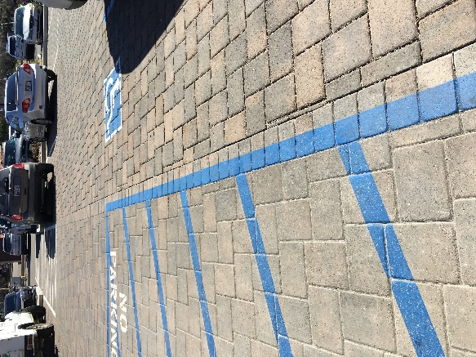
Pervious pavement systems are not recommended in areas designated for ADA parking or an ADA path of travel. Many pervious paver systems require widened joints between pavers, and do not meet the criteria of a firm, stable, non-slip surface. Additionally, gaps in ground surfaces greater than ½ inch horizontally and ¼ inch vertically do not meet ADA criteria. Therefore, even if paver spacing is constructed within this threshold, spacing may vary over time if movement/settlement or damage occurs.
In parking areas where interlocking pervious paver systems will be installed, the County recommends transitioning to standard pavers, asphalt, or concrete in ADA parking stalls and the ADA path of travel as demonstrated in Figure 18. Depending upon the type of system and the fillers installed, some systems may achieve ADA compliance.
Figure 19: Transition from pervious interlocking pavers to traditional pavers in ADA path of travel.

Sedimentation of Infiltration and Filtration Systems
Sediment deposition to infiltration and filtration SCMs poses a significant risk to sustained functionality. Sediment accumulation can reduce the permeability of infiltration surfaces and reduce the usable design life of SCMs. Designers should consider several site characteristics to optimize the functionality and usable life of infiltration and filtration features.
- Identifying and Isolating High-Risk DMAs: Drainage from steep, eroding, or sparsely vegetated areas can generate runoff with significant sediment loads. Similarly travel lanes or parking areas, and areas with high intensity industrial or commercial uses can generate runoff with significant concentrations of gross solids. Drainage from these areas should be isolated, diverted, and/or treated with due consideration of the potential particle loading.
- Pretreatment: A range of approaches can be used to remove sediment and particulates prior to flows reaching filtration and infiltration SCMs. The more commonly used approaches include settling chambers, grassy turf and pretreatment devices.
- Factor of Safety: A factor of safety incorporates more resiliency into the system design and helps maintain the expected level of service as infiltration rates diminish. Utilizing a prudent factor of safety will support the long-term resiliency of the system under variable site conditions.

High Pollutant Risk Sites
Commercial and industrial facilities including gas stations, manufacturing and production facilities, and automotive repair facilities, have greater potential to generate stormwater pollution. Pollutant source controls are an important element of site design for these facilities and should be outlined in the SWCP and O&M Plan.

Source Control Measures
Source control refers to any schedules of activities, prohibitions of practices, maintenance procedures, managerial practices or operational practices that prevent stormwater pollution by reducing the potential for contamination at the source of pollution. While some source control measures can be broadly applied to development, others are site and pollutant specific. Source control measures should be documented in both the SWCP and Operations and Maintenance Agreement

There are three (3) primary types of source controls:
- Structural source controls are physical measures employed to prevent stormwater from contacting work and storage areas to prevent stormwater from picking up pollutants. Examples include berms, containment systems, and permanent shelters.
- Operational source controls are non-structural practices such as employee training, record keeping, good housekeeping, preventative maintenance, spill prevention and cleanup.
- Procedural source controls include implementing process changes such as substituting a less hazardous material for a highly hazardous material in an industrial process.
The SWCP must identify potential pollutants that may be generated once the facility is operational and incorporate appropriate source control measures. Source control measures that are required by the project’s conditions of approval or per State licensing requirements should also be included. A checklist of potential Source Control BMPs is included in the SWCP Template.
Some facilities may also utilize pretreatment devices, such as oil grease separators or vegetated swales, to remove site specific pollutants before stormwater reaches SCMs. This “treatment train” approach removes elevated pollutant loads and ensures that SCMs will continue to function effectively.

Industrial stormwater management
The Statewide General Permit for Stormwater Discharges Associated with Industrial Activities, Order 2014-0057-DWQ (Industrial General Permit) implements federally required stormwater regulations across California for stormwater associated with industrial activities. The Industrial General Permit regulates discharges associated with several federally defined categories of industrial activities (based on Standard Industrial Classification Code), many of which occur at privately operated facilities in San Luis Obispo County. Applicants should consider whether the developed site will be required to enroll in the Industrial General Permit and evaluate options to limit the exposure of industrial activities to stormwater and infiltrate or reuse stormwater onsite. Compliance with the PCRs does not supersede the requirement to enroll in, and comply with, the ongoing requirements of the Industrial General Permit.

Calculations
This chapter provides and describes commonly used and County accepted calculations for analyzing post-construction runoff volumes. These equations and calculations are tailored to support demonstrating compliance with the PCRs.

Tributary DMA Calculations and Tabulations
Several calculations are required for determining retention tributary areas, and the corresponding required retention volume. Each of these calculations should be clearly discernable in submitted SWCPs.

Retention Tributary Area
The first step in sizing structural SCMs is to determine the overall site Retention Tributary Area. This Retention Tributary area is the entire project area except for self-treating or self-retaining areas. that will not produce runoff or create nuisance ponding. DMAs are smaller areas that cumulatively make up the Retention Tributary Area for the entire site. Table 12 provides guidelines for appropriately sizing DMAs.
Once DMAs are delineated and categorized, the retention tributary area can be calculated for each individual Drainage Management Area to facilitate the design of SCMs. Utilize Equation 3 to complete this calculation.
Equation 3: Retention tributary area.
The retention tributary area of a regulated project subject to PR#3 may be adjusted in scenarios with replaced impervious surfaces. Projects outside of approved Urban Sustainability Areas may multiply the amount of replaced impervious surface by 0.5 when calculating the Retention Tributary Area. Per chapter 2, there are currently no USAs in the unincorporated County of San Luis Obispo. A calculation of retention tributary area is demonstrated in Table 18:
Table 18: Adjusted retention tributary area example.
Example Adjusted Retention Tributary Area Example:
Surfaces in DMA | Area
New Impervious Surface | 8,000 sf
Replaced Impervious Surface | 2,500 sf
Total DMA surface Area: | 10,500 sf
Adjusted Retention Tributary Area: (2,500 x 0.5) + 8,000 = 9,250sf

Runoff Retention Volume and Runoff Factors
Projects subject to PR#3 must determine the required runoff retention volume. This volume can be calculated using either flow-based or volume-based sizing requirements. Depending on the WMZ, projects will be required to retain runoff from either the 85th or 95th percentile rainfall event.
The runoff coefficient ‘C’ is calculated for each DMA using Equation 4.
Equation 4: Impervious ratio (i) to Runoff coefficient 'C' equation.
0.78i²
0.858i³
Where i = the fraction of the DMA that is impervious
Once the runoff coefficient C has been determined, the required retention volume can be calculated using Equation 5.
Equation 5: Retention volume calculation.
The required volume of each SCM can be determined using either the Simple Method or Routing Method.

Impervious and Pervious Surfaces
A variety of pervious surfaces are commonly specified for elements of new and redevelopment projects across the County. These surfaces can be beneficial in stormwater management but have limitations that require design consideration. Impervious surfaces have high runoff factors as nearly all rainfall is converted into runoff. Pervious surfaces have varying runoff factors as they can infiltrate a modest volume of stormwater before generating runoff.

Runoff Coefficient Calculation
Runoff factors (C) represent the ratio of stormwater runoff over rainfall that is anticipated for a particular surface type. Impervious surfaces are assigned high runoff factors (0.89) as nearly all rainfall is converted into stormwater runoff. Pervious and semi-pervious surfaces typically have lower runoff factors as a higher ratio of the rainfall is retained in surface features.
Where possible, DMAs can be delineated by surface type. DMAs comprised of more than one surface type should calculate an area-weighted runoff factor per Equation 6 where C represents the runoff coefficient and A represents the area of each surface.
Equation 6: Multi-surface runoff coefficient calculation

Runoff Coefficient C values
Table 19 provides approved Runoff Coefficient ‘C’ values for impervious and pervious surfaces commonly utilized in new and redevelopment projects.
Table 19: Approved C factors for constructed surface types
 | Surface Category | Surface Type | Post-Construction Runoff Coefficient (C)ª
Impervious | Impervious Surfaces | Roofs, concrete, asphalt, grouted pavers. | 0.89
 |  | Bricks or solid pavers over sand base | 0.89
 |  | Grouted rock | 0.89
 |  | Decomposed granite with binder | 0.89
 |  | Dense graded aggregate or dense-graded road base (e.g. Class II, red rock) | 0.89
Pervious | Natural-Pervious | Compacted soil, HSG A or B | 0.15
 |  | Compacted soil, HSG C or D | 0.30
 |  | Decomposed granite without binder | 0.30
 |  | Landscape rock (e.g., cobbles, river rock, pea gravel, etc.) | 0.10
 | Engineered Pervious Surfaces  (designed with sufficient depth to retain the design storm) | Permeable or porous pavers | 0.00
 |  | Pervious concrete or asphalt | 0.00
 |  | Engineered aggregate ^{b} | 0.00
 |  | Artificial turf over subgrade | Use “C” value for subgrade
Notes:
ª Suggested C values only apply where surfaces are underlain by natural site soils with minimal compaction. Surface installations underlain by concrete or impermeable liners are considered impervious. Surface installations underlain by heavily compacted soils should use the C value for compacted soil.
^{b} Open graded aggregate pathways, roadways, or parking areas (e.g. Class I and Class II permeable, No. 57 stone, etc.)

Infiltration and Percolation Rates

Design Infiltration Rates
For all SCMs except bioretention, a factor of safety must be applied to the infiltration rate to account for the risk of the facilities reduced infiltration rate over time. The resulting reduced rate is the design infiltration rate to be used in all calculations. Design infiltration rates based on hydrologic soil groups can also be applied.
Table 20: Design infiltration rates based on Hydrologic Soil Groups
Hydrologic Soil Group | Design Infiltration Rate
A or B | 0.75 in/hour
C or D | 0.25 in/hour

Chapter 4 includes minimum factors of safety for infiltration rates based upon the type of SCM proposed.

Percolation Rate Conversion
Although percolation rates and infiltration rates may be similar, they are not equivalent. As described in Chapter 4, the direct measurements yielded by percolation testing tend to overestimate the infiltration rate. A percolation rate may be converted to an acceptable estimate of the infiltration rate by applying a correction factor using the Porchet Method, Equation 7.
Equation 7: Porchet Method
I_{t}=$\frac{∆H(60r)}{∆t(r+2Havg)}$
Where
∆H = H_{O} – H_{f}
H_{o} = D_{T} – D_{o}; D_{T} (total depth of test hole); D_{o} (initial depth to water)
H_{f} = D_{T} – D_{f}; D_{f} (final depth to water)
r (test hole radius)
∆t (time interval)
H_{avg} = $\frac{Ho+Hf}{2}$

Structural SCM Sizing Calculations
A volumetric SCM must be designed such that a single 95th or 85th percentile 24-hour rainfall event will not overflow the SCM. Calculations for projects not subject to PR#4 may utilize either the simple method or the routing method. Projects subject to PR#4 must use the routing method to address flow rates.

Simple Method and Routing Method
The simple method is single event volume-based calculation and provides values using the retention volume equation for either the 85th or 95th percentile 24-hour rainfall depth. The simple method accounts for the total volume produced by the design storm.

Routing Method
The routing method is a flow-based calculation that accounts for infiltration that occurs simultaneously with inflow during a storm event and results in a smaller SCM footprint. To determine the runoff retention volume using the routing method, additional site characteristics will need to be inputted into a hydrologic modeling program. HydroCAD® is a commonly used program for calculating volumes via the routing method. Routing analyses must adhere to the criteria included in Table 21.
The SCM retention volume must be based on both the rate of flow from tributary areas into the SCM, and the rate of flow out of the SCM through infiltration into the underlying soil during the rain event. If the retention volume cannot fully infiltrate within 48-hours, a multiplier of 1.20 shall be applied to the SCM Capture Volume calculated through the routing method.
For modeling purposes, open, uncovered facilities that retain/detain stormwater with no infiltration (retention ponds, swimming pools, etc.) must be considered impervious surfaces.
Table 21: Routing method criteria.
Parameter | Criteria
Hydrograph Analysis Method | National Resources Conservation Service (NRCS) or Santa Barbara Urban Hydrograph (SBUH).
Pond Routing Method | Storage‐indication, unless otherwise justified to be more correct based on site and storage conditions.
Infiltration Rate | Underlying soil saturated infiltration rate, as indicated by on‐site testing. (See requirements Chapter 4)
Rainfall Distribution | National Resources Conservation Service Type 1* or based on local rainfall data.
Time of Concentration | Identified per County drainage and flood control standards.
Time Increment | 0.10 hour, unless otherwise justified to be more correct based on rainfall distribution.
*The National Resources Conservation Service developed standard 24‐hour rainfall distributions for hydrograph analyses. These rainfall distributions were intended to represent intensities associated with shorter duration storms, ranging from durations of 30 minutes to 12 hours. The National Resources Conservation Service Type storm applies to the California West Coast, including the Central Coast Region. The Type rainfall distribution was derived using National Oceanic Atmospheric Administration Atlas 2 rainfall statistics for the 1‐year through 100‐year storm.

The 4% Rule for Bioretention or Biofiltration Sizing
Bioretention and biofiltration facilities should generally be sized to provide a minimum surface area equal to 4% of the tributary impervious area. There is a simplified method specifically for sizing bioretention facilities meeting the design loading rate (infiltration rate) of 5 inches per hour to detain and treat runoff produced by a rainfall intensity of 0.2 inches per hour. If it is assumed that 100% of rainfall ends up as inflow to the bioretention facility, then the ratio of bioretention surface area to tributary impervious area (or sizing factor) needs to be 0.04 (0.2 in/hr ÷ 5 in/hr) or 4%. This simplified sizing method is demonstrated in Equation 8. This sizing method can be used to demonstrate compliance with PR#2. Additional volume based calculations are required for PR #3. Designs that seek to decrease the minimum surface area below 4% will be required to provide media and materials specifications to the County for review and authorization.
Equation 8: Bioretention facility surface area calculation.
Figure 19 graphically demonstrates the inputs associated with this simplified sizing method.
Figure 20: Simplified sizing method for bioretention facilities.
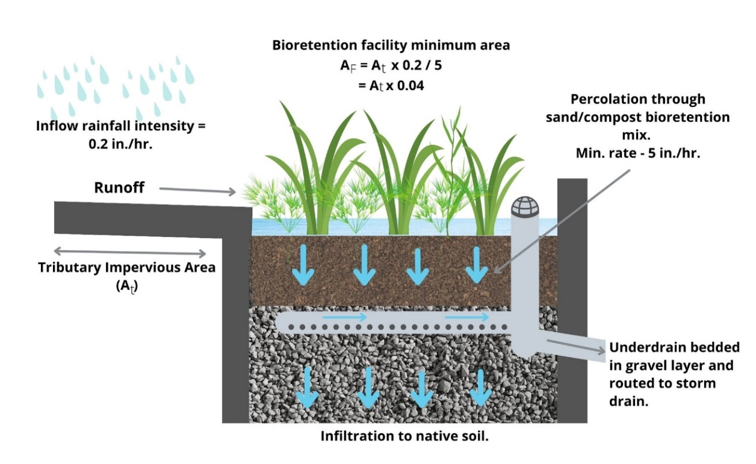

Vegetated swale length and check-dam spacing calculation
The hydraulic residence time in a vegetated swale must be five (5) minutes or longer to achieve adequate water quality treatment. The maximum velocity acceptable within a vegetated swale is 1.0 ft/sec to meet the criteria for PR#2 treatment flow. Installation of check dams may be necessary to reduce velocities and achieve the required residence time. Equations 9 and 10 should be utilized to calculate the swale length and number of check dams necessary to maintain design velocity.
Equation 9: Vegetated swale minimum length calculation
L = 300 (V_{wq})
L= Minimum swale length (feet)
V_{wq} = Design flow velocity (ft/sec)
The 300 seconds multiplier determines the swale length necessary to achieve a hydraulic residence time of at least 5 minutes. Velocity should be calculated using the Manning’s equation.

Equation 10: Vegetated swale check dam spacing calculation
$$N=\frac{L_{swale}x (S-.02)}{H_{dam}}$$
$$L_{dam }= \frac{L_{swale}}{N}$$
Where:
N= number of check dams required
L_{swale} = total length of vegetated swale (feet)
S = longitudinal slope of vegetated swale (feet/foot)
H_{dam}= height of check dams (feet, use maximum height of 1.0)
L_{dam}= distance between check dams (feet)

This equation is simplified and can be adjusted to accommodate specific site conditions and swale configurations.

Santa Barbara Technical Guide Calculator Tool
The Central Coast Stormwater Control Measure Sizing Calculator, available on the Project Clean Water website, facilitates routing method calculations. The calculator MS Excel file should be submitted with your Stormwater Control Plan if utilizing this tool.

Credits for Redevelopment, PR#3
Credit for redevelopment can be achieved by evaluating the Retention Tributary Area and applying an adjustment factor, whereby the total amount of replaced impervious surface area can be multiplied by 0.5. See Table 18 for an example calculation. Evaluation of the redevelopment criteria is encouraged for all previously-developed sites with existing impervious surfaces.

Underground Infiltration Systems and Dry Wells
Underground infiltration systems and dry wells may be used for either retention or detention of site stormwater runoff, where their application is suitable for project conditions. Applicants should reference the criteria for siting underground infiltration system detailed in Chapter 5 and the requirements in Appendix C.

County Drainage and Flood Control Calculations
A project may be subject to additional County drainage and flood control requirements, such as those stipulated in Section 5 – Drainage & Flood Control of the County of San Luis Obispo Public Improvement Standards. A separate Drainage Report is required to address applicable flood control and/or drainage standards. The County generally recommends that the analytic methodology be consistent between the project SWCP and Drainage Report; however, specific requirements of the Public Improvement Standards may vary from those detailed here.

Required Post-Construction Stormwater Submittals
The County requires that all regulated projects submit a complete Stormwater Control Plan Application (SWCP App) and that projects meeting the criteria for PR#2 and above submit a full SWCP utilizing the County provided format. Projects that submit a Stormwater Waiver Request form do not need to submit a SWCP App or SWCP.
Depending on the scope and complexity of the project, the County may also request or require supporting documentation to evaluate the environmental characteristics of affected areas, the potential impacts of the proposed development on water resources, and the effectiveness and acceptability of measures proposed for managing stormwater runoff. Requirements for specific elements of the SWCP are further detailed in this chapter.

Stormwater Control Plan Application (SWCP App)
All regulated projects must complete a SWCP App as part of the construction permit application.
Small scale projects that only trigger compliance with PR#1 must complete the SWCP App but are not required to submit a full SWCP. The plan sheet and detail that demonstrate compliance with selected PR#1 measures must be listed in the SWCP App. The SWCP App provides a summary of key project details and information. Numeric values on the SWCP App are required to match those in the project plans and SWCP (when required).

Stormwater Control Plan, County Template
The SWCP shall be prepared by or under the direction of a qualified professional. The plans must be stamped, signed, and include a certifying statement indicating that all structural SCMs have been designed to meet the County’s stormwater requirements and comply with the PCRs.
To decrease review time, the County of San Luis Obispo SWCP template should be used and followed. The County strongly discourages significant modification, recombination, or deletion of the provided tables in the template. The County may decline to initiate review of SWCPs submitted in formats from jurisdictions outside the Central Coast region. The SWCP template allows for inclusion of additional tables or information as attachments.
Documents that combine County-required drainage reports with the SWCP will not be accepted and will delay the start of project review.

Project Site Data
The SWCP template must be completed with all pertinent project site data. The fields included in this tables are the minimum required information, and applicants may add additional details or narrative information as necessitated by the characteristics of the project.
Data provided in the SWCP must match information provided on plan sheets, supporting reports, and permit application materials. Inconsistencies in project data will require correction before permit review and approval can proceed.

Narrative Portion
The SWCP should be completed with narrative information about the project site and proposed development. In completing the project location and description section applicants should include information pertaining to:
- Project site location description
- Vicinity map
- Parcel boundary modifications (lot splits, lot line adjustments, tract or parcel maps)
- Existing and intended uses
- County zoning
- Setbacks and open space requirements
- Project phasing (if applicable)
- Number of residential units or square footage of commercial space.
- Parking space requirements
- Neighborhood character, including neighboring developments.
This section of the SWCP should also include information about existing site features and conditions. This can include information about notable geographic, topographic and hydrologic features, existing vegetation, or land use. This narrative portion should highlight any of the notable opportunities or constraints associated with existing site features that affect the proposed project design. Applicants are encouraged to carefully review Chapter 4 for detailed information about completing an opportunities and constraints analysis ahead of finalizing the site layout.

Required Exhibits and Details
Several exhibits are required to complete a SWCP in addition to the tables and narrative portions of the SWCP template. Attachment 1 of the SWCP template requires attachment of the following exhibits for all projects requiring a SWCP:
- Pre-existing impervious area exhibit
- Post-project impervious area exhibit (with DMAs and SCMs)
- Net impervious area exhibit (only if applicable)
If a project is required to meet PR#4, the following additional exhibits must be provided:
- Pre-existing modeled conditions exhibit
- Post-project modeled conditions exhibit
These modeling exhibits must show all key information utilized in modeling the hydraulic performance of the SCM system (elevations, basin areas, etc.)

Required Project Plans
Structural SCMs should be clearly shown on project plans with identifying information as follows:
- Number/identification to match number/ID in the SWCP
- Manufacturer and model number
- Grading information (invert in/out, flow line, bottom of basin, top of basin, finish grade/surface, slopes, etc.)
- Inlet and outlet structure(s)
- Volume and/or surface area
- Detail(s)
The design engineer may consider formatting the project plan sheet such that the plan sheet may be used as an exhibit in the SWCP.

Calculations & Tables
The information tables must be filled out completely and not modified from the template, unless otherwise approved by County. Deviations from the calculation methods and formulas detailed in Chapter 6 is strongly discouraged.

Statement of Compliance
The PCRs require that the licensed professional preparing the SWCP include a statement of compliance that each applicable performance requirement has been met. The following statement is included in the template and must remain as part of the SWCP:
“The design of stormwater treatment and retention facilities and stormwater pollution control measures in this plan are in accordance with the Central Coast Region PCRs (Resolution R3-2013-0032) and consistent with the current edition of the County of San Luis Obispo Post-Construction Stormwater Guidebook.”

Opportunities and Constraints Analysis Checklist
The PCRs require an Opportunities and Constraints analysis for projects that trigger PR#3 or PR#4. Additionally, the County requires the Opportunities and Constraints checklist and site map as submittals for projects claiming Technical Infeasibility. The County’s opportunities and constraints checklist is included as Appendix B to this guidebook. The opportunities and constraints checklist and corresponding site map must be included as an attachment to the SWCP for regulated projects PR#3 and above.
Structural Stormwater Control Measures (SCMs)
Structural SCMs must be clearly identified in SWCP text, calculations, figures, and summary tables. Identification includes:
- SCM number/identification
- SCM type
- Sizing calculations
  - Required and provided water quality flow rate or volume

Drainage Report or Drainage Analysis
A formal drainage report is required for projects required to meet flood control requirements, which is separate from the SWCP document. Calculations to meet PR#4 shall be contained within the SWCP to demonstrate the control of peak flows are not exceeding pre-project flows for the 2-year through 10-year storm events.

Operation and Maintenance Agreement
An Operation and Maintenance (O&M) Agreement is required for all projects that utilize SCMs to satisfy PR#2, PR#3, and/or PR#4. A maintenance program is essential to ensure that the stormwater facilities continue to function as designed to maintain water quality and prevent possible flooding and property damage.
A stormwater Condition Compliance Monitoring (CCM) case is the County’s method of tracking long term compliance with post-construction stormwater management requirements. CCM cases are assigned to projects triggering compliance with PR#2 and above and are used to verify that structural controls for managing stormwater runoff are maintained and operational. The Department of Planning and Building will create a CCM case permit and will provide applicants a permanent CCM permit number to reference on the O&M Agreement and permit documents.
A detailed description of the stormwater management system and the operation and maintenance requirements must be recorded with the County of San Luis Obispo Clerk Recorder prior to final of building permits. The recorded O&M Agreement binds current and future owners of the site to maintaining the stormwater drainage system to the design conditions in perpetuity.
The County of San Luis Obispo utilizes two types of Stormwater Operation and Maintenance Agreements for privately owned and operated Post-Construction Stormwater Management Systems. A summary of each type of Agreement and its typical application is further detailed in this section.

Operation and Maintenance Agreements for privately owned development
Projects that construct SCMs on private property in a privately owned development, typically execute single-owner Operations and Maintenance Agreements. The Agreement is made between the County to the system owner and recorded with the County Clerk Recorder. An agreement consists of each of the forms and components listed in Table 22.

Table 22: Components of Private Operations and Maintenance Agreement
Agreement Component | Description: | Applicable Form or Template
Private Stormwater Agreement | Text that documents the purpose of the agreement, terms, and responsibilities of the County and owner. | County form SWP-3001
Owner notarized signature sheet | Notarized signature page acknowledging agreement by the property owner. | County provided form included in SWP-3001. This page may be substituted with notary provided form as necessary.
County notarized signature sheet | Notarized signature page acknowledging agreement by the County. | This form is provided and signed by County staff.
Legal property description | Full legal property description for all parcels affected by the Agreement. | Property descriptions may be retrieved from the Clerks’ office and must be provided by applicants as Exhibit A of the Agreement.
Site Plan | Black and white site map indicating the location and assigned tracking number for each stormwater system component. | This exhibit must be provided by the applicant as Exhibit B of the Agreement.
SCM Descriptions | Detailed description for each element of the constructed system including location, size, capacity, etc. | County form SWP-1007, to be included as part of Exhibit B.
System Owner, Agent, Designer Information | Contact information for the original system owner, system designer and project agent (if applicable.) | County form SWP-1003.
Stormwater System Plans and Manuals Sheets | Information about long-term operations and maintenance requirements and anticipated expenses. A separate form is required for each different feature type. | County form SWP-1008.

The text of the Private Stormwater Agreement requires owners to maintain the stormwater drainage system to the design conditions in perpetuity and formally ties the system to the physical property. Responsibility for operations and maintenance automatically transfers to future owners, heirs, or assigns. Following signature and notarization by both parties, the Agreement is recorded at the Clerk Recorders Office by County staff. Maintenance plans and manuals are retained by the County and attached to the tracking CCM case file.

Operation and Maintenance Agreements for privately owned property held in common ownership
Projects that construct SCMs on private property in a common owner development typically utilize Codes, Covenants and Restrictions (CC&Rs) for documenting long-term stormwater system operations and maintenance requirements. CC&Rs are typical of larger subdivisions, tracts, commercial developments, or multi-family residential developments that will have multiple owners and common or shared areas. Language and information are added to the CC&Rs to require operation, maintenance, and inspection of private stormwater systems. This documentation includes forms consistent with those required for an Agreement.
The CC&Rs language for stormwater systems is similar to language utilized for requiring maintenance and repair of private roads and drainage systems. The CC&Rs must expressly allow for access to private property where components of the system may be located (if not all held on public parcels.) Existing CC&Rs may be amended to include provisions for operation, maintenance, and inspection of stormwater systems.
CC&R language to address stormwater systems typically consists of the following:
Table 23: Components of CC&Rs for stormwater feature operation and maintenance
Agreement Component | Description: | Applicable Form or Template
CC&Rs Language | Information consistent with language and inclusions for the Private Stormwater Agreement | Language and provisions for maintenance sourced from County form SWP-3001
Site Plan | Black and white site map indicating the location and assigned tracking number for each stormwater system component. | This figure must be provided by the applicant as an exhibit.
SCM Descriptions | Detailed description for each element of the constructed system including location, size, capacity, etc. | County form SWP-1007, to be included as an Exhibit.
Stormwater System Plans and Manuals Sheets | Information about long-term operations and maintenance requirements and anticipated expenses. A separate form should be provided for each different feature type. | County form SWP-1008.

Planning and Building staff can review to verify completeness with respect to Stormwater Operation and Maintenance requirements, however, CC&Rs are not countersigned, notarized, or recorded by the County. The final recorded CC&R document number must be provided to Planning & Building for record keeping purposes.

Agreements for SCMs in the public Right-of-Way
Projects that construct SCMs on both public property and private property can utilize a modified Agreement format similar to that of Planning & Building for documenting O&M requirements. The Agreement should include all the components indicated in Table 22 plus an additional exhibit to incorporate a long-term encroachment permit. Long-term encroachment permits are issued by the Department of Public Works to allow maintenance of SCMs in the Right-of-Way. Similarly, the long-term encroachment permit may be referenced as an exhibit in CC&Rs.

SCM Construction and Inspection
Structural stormwater control measures (SCMs) may be constructed at variable phases of project development. While subsurface features may be installed early in the construction process, landscaped surface features may not be constructed until much later. It is critical that the construction team consider the unique attributes of each feature type and provide appropriate protection to ensure proper functioning at the completion of construction.
County issued construction permits include several conditions requiring inspection at different phases of SCM construction. SCM construction checklists are provided in Appendix F. These checklists serve as a record of the site condition and materials used during construction and can be provided to County inspectors to verify compliance and conformity with approved plans.

Construction and Inspection Checklists
The checklists included in Appendix F may be referenced on the project plans to ensure proper construction practices are followed and necessary milestone inspections are completed for each type of SCM.

Inspection Process and Frequency
The project’s construction permits will include specific conditions for inspection of drainage features and SCMs throughout the construction process. Site staff should maintain records of all delivered materials, photographic records of the installation process where subsurface features are installed, and maintain records of third party contractor or Engineer of Record inspections. These records should be provided to County as part of project closure.
Below are typical required inspection milestones for different types of SCMs. These inspection milestones may vary based on specific project details.

Subsurface Stormwater Feature: (ex. Treatment Vault/Infiltration Chamber)
- Excavation
- Geotextile fabric installation
- Gravel placement
- Structure placement
- Inlet, outlet and pretreatment device
- Backfilling
- Final surface construction and connection

Biofiltration or Bioretention Stormwater Feature:
- Excavation
- Gravel placement
- Bioretention soil media installation
- Piping, underdrain structures
- Vegetation plantings, mulch installation
- Final restoration

Pervious Pavers: (ex. Pervious or Permeable Pavers, Porous Concrete)
1.Excavation
2. Geotextile fabric placement
3. Gravel placement
4.Paver placement or porous concrete installation
5. Joint gravel or sand
6. Final

Detention Stormwater Feature (ex. Detention Basin)
- Excavation
- Inlet and outlet construction
- Final (fully stabilized)
Developers are responsible to coordinate milestone inspections of all subsurface features and treatment measures prior to installing final cover.

Materials Specifications and field slips
It is the responsibility of the contractor and design engineer to ensure that construction materials conform to the approved design and details. Substitution of specified materials must be approved by the design engineer or architect. Materials field slips should be retained to confirm conformity with the approved plans, and provided to the County for permanent records.

Documenting field changes
Due to the intensely site-specific nature of SCMs and precise sizing requirements, the County requires that any field changes that modify the dimensions or volume of any single SCM by more than 10% require updated permit submittals.
Documentation of after-issuance changes is critical to ensuring that the project will maintain compliance with the PCRs. Completion and filing of a Change Order to Issued Permit (Form BLD-1003) is required for all changes to the issued construction permit. Additional documentation may be necessary including as-built grading plans, utility plans, or an amended SWCP. Non-conformity with the job copy of issued permits can significantly delay the final closeout of construction permits.
Any changes to SCMs located within public right-of-way may also require revision of Public Improvement Plans and may require additional documentation for County Department of Public Works.

Engineer’s Certification
Final Certification is required by the Engineer of Record or Work who designed the stormwater infrastructure. This includes approval that all construction materials installed conform with design specifications, system was constructed in conformance of approved design, and final inspection was completed and approved. This is required as part of final closure of the permit.

Overview of Operations and Maintenance Agreements
Lack of source control, site design, or SCM maintenance can be a be a cause of failure of SCMs due to significant impacts from delivery of runoff and pollutants. Stormwater SCMs are by their nature subject to deposition of solids such as sediment, trash, and vegetative debris. Some structural SCMs are also subject to growth of vegetation, either by design (e.g. bioretention) or incidentally. Maintenance to remove pollutants and manage vegetation must be done periodically for the life of the property to ensure the capacity of the SCMs to treat, infiltrate, and retain stormwater. Structural components of some SCMs are also at risk of clogging from collected debris and overgrowth of vegetation or invasive plants. Clogged SCMs can result in lengthened draw down times and potentially result in flooding, or prolonged standing water that creates mosquito breeding habitat. Proper operation and maintenance are critical to ensure the long-term functionality of LID features and SCMs across the project site.

This chapter provides an overview of the County’s Operations& Maintenance agreements for ensuring long-term operation and maintenance of SCMs on private property and long-term encroachment permits for SCMs located in the County’s Right-of-way.

Roles and Responsibilities Operations & Maintenance on Common Property
Maintenance, inspection, and repair of all SCMs on common land (those held by Home Owners Associations or HOAs) are the responsibility of the HOA. This responsibility runs with the land and must be legally recorded, executed, and transferred upon sale of the property.

The HOA is responsible for inspecting and/or ensuring the inspection by a qualified professional, of all SCMs at least once a year and at the frequency specified in the maintenance and inspection section of the SWCP. The funding of all inspection, maintenance, repairs, and reporting of SCMs on common land is the sole responsibility of the HOA.

For projects with SCMs located within a common area or easement to be maintained by a HOA, language regarding the responsibility for inspection and maintenance must be included in the project’s CC&R’s. In addition, the CC&R’s must include the location and brief description of all stormwater SCMs installed with the project, and any required maintenance. This language will be reviewed and approved by the Department of Planning & Building as part of the Final SWCP approval process.

Annually, the HOA (or a representative) must complete a self-inspection and certification of the Stormwater Management System verifying continued functionality. County staff will notify HOA representative (via email or direct mailing) of the need to complete and submit inspection forms each year.
Completion of the annual inspection forms is tracked by the CCM Permit case number issued by the Department of Planning & Building. Self-inspection forms may be obtained from Planning and Building’s website and must be completed and submitted by June 15th of each year.
The County does not require that property owners hire a certified professional to conduct the annual inspection. However, property owners and managers are authorized to hire a licensed or certified professional to conduct the inspection on their behalf. The funding of all inspection, maintenance, repair, or replacement of SCMs on private land is the sole responsibility of the property owner.

Roles and Responsibilities for Operations & Maintenance on Private Property
Maintenance and Inspection of all SCMs on private land are the responsibility of the property owner. Small stormwater systems owned and operated by a single owner are typically protected by an operations and maintenance Agreement recorded with the County Clerk-Recorder. The Agreement runs with the land, and is transferred to successive owners, heirs, executors, administrators, assigns and successors in interest. Additionally, a copy of this Agreement should be included in any sales and/or lease agreements.

Annually, the current property owner (or representative) must complete a self-inspection and certification of the Stormwater Management System verifying continued functionality. County staff will notify property owners or managers (via email or direct mailing) of the need to complete and submit inspection forms each year.
Completion of the annual inspection forms is tracked by the CCM Permit case number issued by the Planning & Building Department. Self-inspection forms may be obtained from Planning and Building’s website and must be completed and submitted by June 15th of each year.
The County does not require that property owners hire a certified professional to conduct the self-inspection. However, property owners and managers are authorized to hire a licensed or certified professional to conduct the inspection on their behalf. The funding of all inspection, maintenance, repair, or replacement of SCMs on private land is the sole responsibility of the property owner.

Roles and Responsibilities for Operations & Maintenance on Public Property
Project developers and owners are encouraged to site SCMs within the limits of their private property on the project site. However, in cases where proposed SCMs are required to treat/mitigate storm water runoff from public improvements, required as part of the project or existing public right of way that drains into the project area, SCMs may need to be located in the public Right-of-Way.

If SCMs are proposed in a public area the SCMs must meet narrower design guidelines than those specified in this Guidebook. Early consultation with County Public Works is strongly advised for determining specific regulations related to SCMs in the Right-of-Way. Inspection and maintenance will remain under the project or property owner’s responsibility until the project conditions are met.

Once construction is complete, a long-term encroachment permit will be issued for SCMs located in the County’s Right-of-way to allow for private maintenance. This long-term encroachment permit allows a private entity to maintain SCMs located in the public right-of-way using maintenance indemnification agreement. However, if any SCMs are formally transferred and accepted to public ownership, this long-term encroachment permit will be terminated. Once the SCMs are legally transferred and accepted, the maintenance, inspection, and replacement are the responsibility of the County.

Inspections and maintenance following construction completion
The plans and manuals included with the SWCP and Operation and Maintenance Agreement must specify the frequency of inspection and maintenance for each type of SCM installed at the project site. Site owners/operators are strongly encouraged to review the inspection and maintenance requirements of the proposed features with their design/engineering firm prior to authorization of construction.
The County recommends that any interim or periodic inspections specified by the O&M agreement be completed and documented although only annual inspections must be reported to the County. Records regarding inspections and maintenance should be retained for at least five years and made available upon request to the County. These records may include copies of completed inspection reports and maintenance checklists to document any inspection and maintenance activities that were conducted over the preceding five years. Corrective actions, repairs, or replacements should also be documented and maintained with SCM inspection and maintenance records for a minimum of five years.

Common maintenance findings
SCMs require regular maintenance to function effectively during storm events. Common SCM maintenance activities include, but are not limited to:
- Clean pre-treatment devices and drain inlets (filters, screens, etc.) of soil, litter, and debris.
- Replace mulch, bioretention soil media, and surface cover material.
- Treat or replace dead or diseased vegetation.
- Remove sediment buildup in structures, basins, and underground chambers.
- Weeding, mowing, pruning, and replacing of vegetation.
- Cleanout or replace rip-rap rock at outlet discharge locations.
- Remove any incidental litter or debris.

Mechanism to assure continued operations
While many SCMs have minimal ongoing maintenance needs, the County is required to assure that all infrastructure required by the PCRs is continuously functional. Destruction of SCMs for a modified site use or significantly degraded functionality may prompt intervention by County enforcement staff.

Destruction or prolonged failure to maintain SCMs that results in compromised functionality would constitute a public nuisance, which may be abated under the Uniform Public Nuisance Abatement Procedure. This enforcement mechanism would allow costs of maintenance to be billed to the owner, a lien placed on the property, and the tax collection process to be used.

For projects whose land use approval included ongoing conditions for post-construction stormwater management, project-specific conditions typically include a requirement for the owner of the land to maintain that facility in accordance with the requirements specified in the maintenance plan. Failure to perform maintenance may then be addressed as a violation of the land use permit, under the ordinance governing that permit process.

Termination of Operations and Maintenance Agreements
There are limited cases where the County may terminate an operations and maintenance agreement with a property owner. The termination process is initiated by the Department of Planning & Building under merited circumstances such as annexation or property destruction.

Annexation into an incorporated City
Properties that completed construction and enrolled in the County’s operations and maintenance program while in County jurisdiction are terminated from the program upon annexation to an incorporated city. Once annexation is completed, property owners are relieved of completing annual inspections through the County’s process and will be directed to enroll in the incorporated City’s operations and maintenance program.
The County will notify annexed properties of the intent to terminate their Operations and Maintenance Agreement and will file a Notice of Termination for the Agreement with the County Clerk Recorder. Digital case records associated with the property including prior year’s inspection forms, maps, and SWCP will be provided to the annexing jurisdiction. No fees will be charged by the County for terminating agreements due to annexation.

Destruction by catastrophic event
The County may elect to terminate an operations and maintenance agreement following a natural disaster, declared emergency, or catastrophic event that requires subsequent demolition of the enrolled property.
County staff will evaluate the necessity of terminating operations and maintenance agreements on a case-by-case basis in these circumstances.

Removal of SCM and restoration to pre-construction conditions
The County may consider a request to terminate an operations and maintenance agreement if improvements associated project are removed and site is restored to pre-construction conditions (native pervious materials). This will require submittal of a County of San Luis Obispo Grading Permit Application for approval for these demolition activities.

Bibliography and References
City of Gilroy, City of Morgan Hill, County of Santa Clara. 2015. “Stormwater Management Guidance Manual for Low Impact Development & Post-Construction Requirements.” https://stgenpln.blob.core.windows.net/document/Stormwater_GuidanceManual_PostConstructionRequirements.pdf

City of Salinas. 2021. “Stormwater Development Standards for New and Redevelopment Projects.” https://cityofsalinas.org/sites/default/files/departments_files/public_works_files/water_solid_waste_energy/swds/complete_swds_final_august_2021_md_rev.pdf

City of San Diego, 2018. “The City of San Diego Storm Water Standards.” https://www.sandiego.gov/sites/default/files/storm_water_standards_manual_oct_2018.pdf

County of Sonoma. 2017. “Storm Water Low Impact Development Technical Design Manual, Revised December 2020.” https://www.srcity.org/1255/Low-Impact-Development

County of Santa Barbara, Project Clean Water. 2017. “Stormwater Technical Guide for Low Impact Development, 2nd Edition.” https://www.countyofsb.org/2324/New-Redevelopment

County of Orange. 2017. “South Orange County Technical Guidance Document for the Preparation of Conceptual/Preliminary and/or Project Water Quality Management Plans.” https://ocerws.ocpublicworks.com/service-areas/oc-environmental-resources/oc-watersheds/regional-stormwater-program/water-quality

California Department of Transportation, Division of Environmental Analysis. 2012. Biofiltration Swale Design Guidance. https://dot.ca.gov/-/media/dot-media/programs/design/documents/dg-biofiltration-swale-092712-a11y.pdf
California Department of Transportation, “Biofiltration Strip Design Guidance” https://dot.ca.gov/-/media/dot-media/programs/design/documents/1_dg-biofiltration_strip_ada.pdf
Contra Costa Clean Water Program, 2022. Stormwater C.3 Guidebook, 8th Edition. https://www.cccleanwater.org/development-infrastructure/development/stormwater-c-3-guidebook

County of San Diego. 2020. “County of San Diego BMP Design Manual.” 2nd update to February 2016 Manual. https://www.sandiegocounty.gov/content/sdc/dpw/watersheds/DevelopmentandConstruction/BMP_Design_Manual.html

Santa Clara Valley Urban Pollution Prevention Program (SCVURPPP), 2016. Guidance for Implementing Stormwater Requirements for New Development and Redevelopment Projects (C.3 Stormwater Handbook) https://scvurppp.org/swrp/gsi/

Riverside County LID BMP Handbook, Riverside County Flood Control and Water Conservation District, 2011. https://rcwatershed.org/permittees/riverside-county-lid-bmp-handbook/#93-98-1-lid-bmp-design-handbook

State of Washington, Department of Ecology. Emerging Stormwater Treatment Technologies (Technology Assessment Protocol- Ecology TAPE) Guidance Documents. 2018. https://ecology.wa.gov/Regulations-Permits/Guidance-technical-assistance/Stormwater-permittee-guidance-resources/Emerging-stormwater-treatment-technologies

Central Coast Low Impact Development Initiative (LIDI), 2013. “Bioretention Engineering Standards: Details and Technical Specifications.” https://www.centralcoastlidi.org/projects.php

California Building Standard Commission (CBSC). 2022. “California Buildings Standards Code.” http://www.bsc.ca.gov/Codes.aspx

California State Water Resources Control Board. 2022. “National Pollutant Discharge Elimination System General Permit for Stormwater Discharges Associated with Construction and Land Disturbance Activities.” Order WQ 2022-0057-DWQ https://www.waterboards.ca.gov/water_issues/programs/stormwater/construction/docs/2022-0057-dwq-with-attachments/cgp2022_order.pdf

California State Water Resources Control Board. 2014. “National Pollutant Discharge Elimination System General Permit for Storm Water Discharges Associated with Industrial Activities.” Order 2014-0057-DWQ. https://www.waterboards.ca.gov/water_issues/programs/stormwater/docs/industrial/2014indgenpermit/order.pdf

Central Coast Regional Water Quality Control Board. 2013. “Central Coast Post-Construction Stormwater Requirements.” Order No. R3-2013-0032. https://www.waterboards.ca.gov/centralcoast/water_issues/programs/stormwater/docs/lid/lid_hydromod_charette_index.html

California Department of Water Resources. “Model Water Efficient Landscape Ordinance.” https://water.ca.gov/Programs/Water-Use-And-Efficiency/Urban-Water-Use-Efficiency/Model-Water-Efficient-Landscape-Ordinance

San Luis Obispo County Municipal Code. 2022. Title 19.11, Buildings and Construction. https://library.municode.com/ca/san_luis_obispo_county/codes/county_code?nodeId=TIT19BUCO_CH19.11STMA

San Luis Obispo County Municipal Code. 2022. Title 8.68, Stormwater Pollution Prevention and Discharge Control. https://library.municode.com/ca/san_luis_obispo_county/codes/county_code?nodeId=TIT8HESA_CH8.68STPOPRDICO

