NOTICE OF CANCELLATION

PASO BASIN COOPERATIVE COMMITTEE

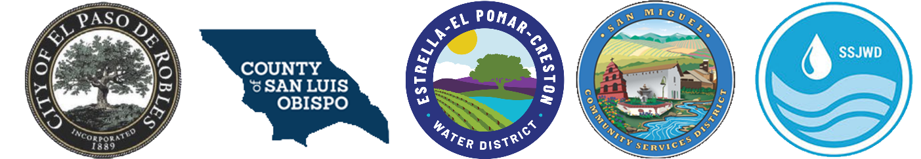

PBCC Meeting Cancellation
Notice is hereby given that the Regular Paso Basin Cooperative Committee (PBCC) meeting scheduled for Wednesday, March 26, 2025, has been cancelled.

Annual Report Comments
As a reminder, the draft Water Year 2023-2024 Paso Basin Annual Report public comment period concludes March 26, 2025. If you have any comments, please email them to gw_groundwater@co.slo.ca.us by March 26, 2025. To access the draft report, please download here: Public Draft WY 2024 Annual Report.

Furthermore, once the report has been uploaded to the California Department of Water Resources SGMA portal/website (due April 1, 2025), public comment can be provided directly on the DWR website by searching for the “Paso Robles Area” and selecting the current Water Year 2023-2024 report. https://sgma.water.ca.gov/portal/gspar/submitted

