
Thursday December 18th, 2025
1300-1400 in Sierra Vista Auditorium and On Zoom
Base Station: Neurosurgical Emergencies
Presenter: Dr Benjamin Hendricks
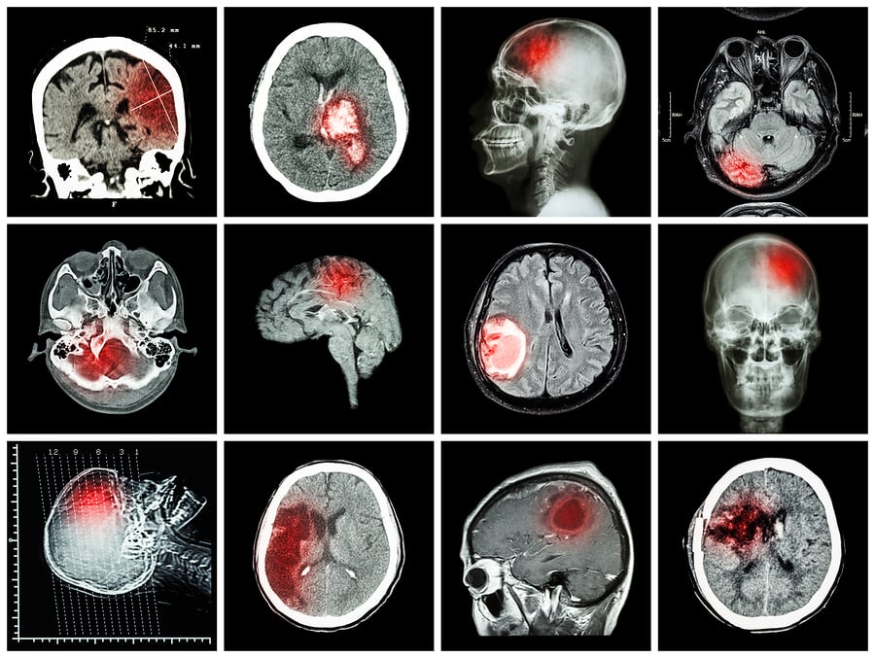

This Base Station will also be available on Zoom. For Zoom details please email Maren
Masterson BSN, RN at masterkm01@ah.org.

Provider approved by the CA BRN, Provider Number 18040 for 1.0 CE Contact hours. EMS CE
Provider Number 40-0011 for CE Contact Hours. Counts for 1 Base Station and must attend at
least 50 minutes for credit.

